Preliminary Report of Sky Luminance Investigation
Cherenkov Telescope Array Site Evaluation
Canary Islands and Northern Argentina Sites

Dan Duriscoe
U.S. National Park Service Night Skies Program
dan_duriscoe@nps.gov

INTRODUCTORY
The U.S. National Park Service Night Skies Program is recognized for calibrated high resolution night sky brightness measurements over the entire hemisphere of the sky using a wide-field CCD camera and optics approximating the Johnson-Cousins V photometric band. In addition, a model of the natural sky luminance for a given site, airglow intensity, and atmospheric extinction is constructed in order to estimate the anthropogenic component of sky luminance. A single data set is comprised of 45 square format images obtained over a period of about 20 minutes using a portable robotic telescope mount. The methods are described in Duriscoe, Luginbuhl, and Moore (2007) and Duriscoe (2013).
This equipment was utilized at a site in the Canary Islands and two sites in Argentina in June of 2013. Equipment malfunction at one the southern Argentina site of El Leoncito prevented the acquisition of useable data. Data from the remaining sites were calibrated and mosaicked into fisheye and panoramic projections. The original resolution of the mosaics is about 34 million pixels/hemisphere. These are resampled to 0.05 degrees per pixel (8.25 million pixels/hemisphere) for analysis.
Data products include the full resolution calibrated (in V magnitudes per square arc second) mosaics, background sky brightness all sky maps, and a map of estimated anthropogenic sky glow derived from a subtraction of a customized natural sky model for each data set. Simple analyses are presented in this preliminary report, including sky brightness statistics, horizontal illuminance, and maximum vertical illuminance from the sky for both the total sky brightness and the estimated anthropogenic component only. Tables of sky brightness in nano-Lamberts, micro-candela per meter squared, and V-magnitudes per square arc second over a two degree grid are provided in Excel files for each data set.

DATA COLLECTION
Field work was performed by Lawrence Wasserman of Lowell Observatory. He was at Teide Observatory on Tenerife, Canary Islands on the nights of 6/3, 6/4 and 6/5. Observations were made at the proposed CTA site a few km from the Observatory on the night of 6/5. The other two nights were cloudy. He was assisted by Irene Puerto. From there, he went to the CTA site in northern Argentina, staying in the small town of San Antonio de Cobres. The CTA site is about 20 km from San Antonio. We arrived late on 6/8 and did not try to observe. However we did observe on the nights of 6/9 and 6/10. I was assisted by Beatriz Garcia, Natalia Serre, and George. George was our driver. After looking at the data, it appears that there were some clouds on 6/9, but that 6/10 was clear. Due to fog in Buenos Aires, the flight out of Salta was cancelled and arrival at El Leoncito Observatory (about 10km from the southern CTA site) was a day later than expected. Data was taken on the nights of 6/12 and 6/13. The weather was good, but we later found out that we had shutter problems with the camera and no useful data was obtained. He was assisted by Javier Maya.
NATURAL SKY MODEL
A natural sky brightness model mosaic was built for each data set. The model consists of three main components: the Milky Way, the Zodiacal Light, and the natural airglow. The Milky Way and Zodiacal models are fixed in their respective coordinate systems, and are modified to reflect the effects of atmospheric extinction unique to each data set. The Milky Way model (integrated starlight and diffuse galactic light) was constructed from data from many nights at remote clear sky locations with the NPS camera, but includes surrogate V-band photometry from another source for regions near the south celestial pole. The airglow is the most difficult to model accurately, especially on nights when it is relatively bright.
At the Canary Islands site, values for zenith airglow were estimated at from 38-51 nL, among the brightest ever observed with this system. Under these conditions, it is difficult to accurately measure the anthropogenic component of sky brightness at the zenith. While we report an error of ±8 nl under good airglow conditions, on the night at Canary Islands site it is estimated at ±15 nL, especially in data sets 3-6. At the northern Argentina site, the airglow was much dimmer, with values of 10-22 nL used. This, combined with near certainty that no anthropogenic sky glow exists at the zenith, allowed a much better fit of the airglow model.
RESULTS
A summary of all-sky statistics appears in Tables 1-3. A complete set of mosaicked sky luminance maps are presented as all-sky images in Lambert Azimuthal Equal Area Projection (Fisheye) and Hammer Aitoff Equal Area Projection (Panoramic) in Figures 1-60. These images provide at-a-glance results and are fairly easy to interpret. Each uses the same false color ramp in V-magnitudes per square arc second (logarithmic) allowing direct comparison mimicking how the human eye my perceive the sky brightness. The "Full resolution mosaics" are the most illustrative of details in the airglow, Milky Way, and city light domes. The resampled "Background sky brightness" maps at 0.05 degrees per pixel are filtered to remove most of the stars and are used in the analysis. The "Estimated Anthropogenic sky glow" is the observed sky brightness minus the natural sky model. An Excel workbook with sheets of sky brightness values extracted from the mosaics as a bilinear interpolation of a two degree radius circular neighborhood for each data set is included in digital media as a data supplement. The sky brightness maps are also available in the supplementary material, and may be viewed in higher resolution than the representations in this report by accessing these images.
DISCUSSION
There are significant differences between the two sites in terms of anthropogenic sky glow (see Figures 1-2, 21-22, 41-42). While both appear to be nearly free of sky glow at the zenith, the Canary Islands site exhibits far more influence from the glow of cities and towns along the horizon than the Northern Argentina site. Also, there was considerably more natural airglow on the night at Canary Islands than either of the nights at San Antonio. This was difficult to model and remove accurately to derive the estimate of the anthropogenic component, some airglow artifacts may be seen in the all-sky maps. The first two data sets are superior (Figures 9, 10, 15, and 16), as the airglow appeared to increase and develop character as the night progressed. Both nights at San Antonio appeared to have relatively low amounts of airglow, exhibited in the incredible contrast between the Milky Way and Zodiacal light and the remaining sky background (see Figures 25 and 45).
A comparison of several sky quality indicators may be made from Tables 1-3. Table 1 lists attributes for the Canary Islands data night, and some important statistics from the background sky luminance mosaic and the estimated anthropogenic sky glow mosaic. The extinction coefficient in V-magnitudes per airmass, as determined by all-sky aperture photometry of standard stars, is quite low for this site elevation above sea level at . The Zenith sky brightness is strongly affected by the airglow early evening; by early morning, though, a combination of bright airglow the Milky Way passing overhead make interpretation of this number difficult. All-sky luminous emittance is an unbiased scalar measure of the sum of luminous flux coming from the background sky luminance regardless of direction. A sky with moderate airglow and no anthropogenic sky glow will produce about 1.56 mLux all-sky luminous emittance. This corresponds to an average sky luminance of 78 nL. Horizontal illuminance is also important to astronomy, since it is biased toward the Zenith. Median value for a natural sky for this measure is about 0.8 mLux. Vertical illuminance will be produced by a city light dome; the average for the natural night sky is about 0.4 mLux (in the absence of light domes). All three of these reference values will increase on nights with bright airglow, the values above represent a median over the 11 year sunspot cycle. This is important, since the sky brightness data reported here correspond to approximate sunspot maximum. The second part of Table 1 displays these statistics for the estimated anthropogenic sky glow mosaic (after the natural sky model is subtracted from the data mosaic), and expressed in both mLux and as a ratio to the median natural conditions.
It can be seen from Table 1 that all-sky light pollution ratios (all-sky luminous emittance and average sky luminance) average about 0.4. That is, about 40% above median natural levels. At the zenith only, the ratio averages about 0.1, or 10% above natural. Maximum vertical illuminance, however, for this site averages about 0.8 or 80% above natural. Also, the brightest part of the sky varies from 19 skies (where 1 sky = 54 nL or 22.0 mag arcsec⁻²) in the evening to about 10 skies in the early morning hours. The brightest values are observed near the horizon in the direction of the brightest light dome, presumably from Santa Cruz de Tenerife.
Table 2 lists the same data for the Northern Argentina site on the night of June 9-10, 2013, and Table 3 data for the following night at this location. The second night (Table 3) is superior in data quality because the high and low clouds evident on the first night were absent, only a line of clouds near the horizon to the north. However, data from both nights reveal exceptionally dark conditions with only three small light domes appearing to influence the area of the sky between the horizon and 10 degrees elevation, the brightest from San Antonio de Cobresat about 205 degrees azimuth (see Figures 41 and 42). In Figure 42, the bright blob above the city light dome is the Large Magellanic Cloud; unfortunately both the large and small clouds are missing from the natural sky model and their appearance in the sky glow mosaic results in them being interpreted as light pollution. The total combined light interpreted as anthropogenic is small, however, as seen by the LPR for average anthropogenic sky luminance in Table 3, averaging 0.07. Even the maximum vertical illuminance is small, averaging about 0.1, excluding data set 1, where stray light from a flashlight was caught in a data frame (Figure 43, lower left). This site is definitely remarkable in its remoteness from city sky glow.
CONCLUSIONS
Both sites possess good sky quality in terms of absence of visual band anthropogenic sky glow near the Zenith. However, the San Antonio de Cobres site in northern Argentina reveals nearly pristine conditions from zenith to horizon. The Canary Islands site appears to be significantly influenced by sky glow from cities and towns in the area of the sky from approximately elevation angle 0 degrees to 30 degrees.
REFERENCES
Duriscoe, D.M., Luginbuhl, C.B., and Moore, C.A., 2007. Measuring night-sky brightness with a wide-field CCD Camera. PASP, 119:192.
Duriscoe, D.M., 2013. Measuring anthropogenic sky glow using a natural sky brightness model. MNRAS, submitted for review.

Data Night Attributes, National Park Service Night Skies Program
Teide Observatory (Canary Islands) Site, June 5-6, 2013
PARK: |  | Cherenkov Telescope Array |  |  |  |  |  |  | EQUIPMENT: |  |  | SBIG1, 50mm f/2, 8582
SITE NAME: |  | Teide Observatory Canary Islands |  |  |  |  |  |  | OBSERVERS: |  |  | L Wasserman
LONGITUDE: |  | -16.54411 |  |  |  |  |  |  | AIR TEMP (°F): |  |  | 50.5
LATITUDE: |  | 28.27395 |  |  |  |  |  |  | REL HUMID (%): |  |  | 6
ELEVATION (m): |  | 2292 |  |  |  |  |  |  | WIND SP (mph): |  |  | 9
DATE (UT): |  | June 5, 2013 |  |  |  |  |  |  | CCD TEMP (°C): |  |  | -20
TIME START (UT): |  | 22:09:57 |  |  |  |  |  |  | EXP (seconds): |  |  | 16
DATA QUALITY: |  | Excellent |  |  |  |  |  |  | BORTLE CLASS: |  |  |  |  |  | ZLM:
NARRATIVE: Very clear, exceedingly dry.
SUMMARY OF ALL SKY PHOTOMETRY FOR EACH DATA SET
Data Set | Local Mean Time at middle (hours) |  | Extinction Coefficent (magnitudes/airmass ±0.01) | Std. Error of Y Extinction Regression (magnitudes) | Sky Quality Index | Synthetic SQM |  | Zenith Sky Brightness (magnitudes/sq arc sec ±0.04) |  | Brightest area of the Sky (magnitudes/sq arc sec ±0.04) | All-sky luminous emittance (mLux ±0.01) |  | Horizontal Illuminance (mLux ±0.01) | Maximum Vertical Illuminance (mLux ±0.01) | Notes
1 | 21.22 |  | 0.14 | 0.031 | 84.9 | 21.43 |  | 21.69 |  | 18.73 | 2.79 |  | 1.14 | 0.85
2 | 22.15 |  | 0.13 | 0.031 | 77.6 | 21.33 |  | 21.59 |  | 18.89 | 3.03 |  | 1.24 | 0.99
3 | 23.07 |  | 0.13 | 0.031 | 79.8 | 21.26 |  | 21.59 |  | 19.08 | 3.10 |  | 1.30 | 0.98 | Airglow increasing
4 | 24.00 |  | 0.13 | 0.032 | 81.7 | 21.20 |  | 21.50 |  | 15.78 | 3.17 |  | 1.35 | 1.02
5 | 0.92 |  | 0.13 | 0.035 | 86.8 | 21.14 |  | 21.44 |  | 19.45 | 3.12 |  | 1.37 | 0.94 | Very bright airglow
6 | 1.85 |  | 0.13 | 0.030 | 82.1 | 21.16 |  | 21.26 |  | 19.15 | 3.30 |  | 1.40 | 1.01
Table 1. Photometric statistics for the Canary Islands Site on June 5-6, 2013.

Estimated Anthropogenic Sky Glow
Illuminance (mLux), Luminance (nL) and Ratio of Light Pollution to Natural Conditions (LPR)
Data Set | All-Sky Luminous Emittance (±0.05 mLux) |  |  | Vertical Illuminance |  |  |  |  |  | Horizontal Illuminance (±0.05 mLux) |  | Sky Luminance
 |  |  |  | (±0.05 mLux)
 |  |  |  | Maximum |  | Average |  | Minimum |  |  |  | Brightest |  | Zenith |  | Average
 | mag | mLux | LPR | mLux | LPR | mLux | LPR | mLux | LPR | mLux | LPR | nL (±30) | LPR (skies) | nL(±15) | LPR (skies) | nL(±5) | LPR
1 | -5.81 | 0.54 | 0.34 | 0.25 | 0.63 | 0.16 | 0.40 | 0.06 | 0.15 | 0.14 | 0.17 | 1024 | 19.08 | 6 | 0.11 | 27.7 | 0.35
2 | -6.21 | 0.78 | 0.49 | 0.37 | 0.93 | 0.23 | 0.56 | 0.10 | 0.25 | 0.24 | 0.29 | 838 | 15.61 | 11 | 0.20 | 40.4 | 0.50
3 | -6.03 | 0.66 | 0.41 | 0.31 | 0.78 | 0.19 | 0.48 | 0.10 | 0.24 | 0.21 | 0.26 | 699 | 13.01 | 5 | 0.10 | 34.2 | 0.43
4 | -6.00 | 0.64 | 0.40 | 0.34 | 0.84 | 0.19 | 0.46 | 0.07 | 0.18 | 0.19 | 0.24 | 697 | 12.98 | 6 | 0.12 | 33.1 | 0.41
5 | -5.53 | 0.42 | 0.26 | 0.18 | 0.46 | 0.12 | 0.30 | 0.05 | 0.14 | 0.13 | 0.16 | 493 | 9.18 | 7 | 0.13 | 21.5 | 0.27
6 | -5.96 | 0.62 | 0.39 | 0.27 | 0.67 | 0.18 | 0.46 | 0.08 | 0.19 | 0.16 | 0.21 | 590 | 10.99 | 5 | 0.09 | 32.1 | 0.40
Table 1. Continued, showing estimated anthropogenic sky glow statistics for the Canary Islands Site, June 5-6, 2013.

Table 2. Photometric statistics for the Northern Argentina site on June 9-10, 2013.
Data Night Attributes, National Park Service Night Skies Program
San Antonio de Cobres (N. Argentina) Site, June 9-10, 2013
PARK: |  | Cherenkov Telescope Array |  |  |  |  |  |  | EQUIPMENT: |  |  | SBIG1, 50mm f/2, 8582
SITE NAME: |  | San Antonio de Cobres (N. Argentina) |  |  |  |  |  |  | OBSERVERS: |  |  | L Wasserman
LONGITUDE: |  | -66.23486 |  |  |  |  |  |  | AIR TEMP (°F): |  |  | 45
LATITUDE: |  | -24.04523 |  |  |  |  |  |  | REL HUMID (%): |  |  | 34
ELEVATION (m): |  | 3622 |  |  |  |  |  |  | WIND SP (mph): |  |  | 4
DATE (UT): |  | June 9, 2013 |  |  |  |  |  |  | CCD TEMP (°C): |  |  | -20
TIME START (UT): |  | 23:44:29 |  |  |  |  |  |  | EXP (seconds): |  |  | 16
DATA QUALITY: |  | First 2 sets OK, high clouds move in after |  |  |  |  |  |  | BORTLE CLASS: |  |  |  |  |  | ZLM:
NARRATIVE: Low clouds at start 10%, one cloud reflects light on 2nd set, 3rd and later high clouds move in, by 6th set covering entire sky. Very transparent at start. Aiglow very low throughout.
SUMMARY OF ALL SKY PHOTOMETRY FOR EACH DATA SET
Data Set | Local Mean Time at middle (hours) |  | Extinction Coefficent (magnitudes/airmass ±0.01) | Std. Error of Y Extinction Regression (magnitudes) | Sky Quality Index | Synthetic SQM |  | Zenith Sky Brightness (magnitudes/sq arc sec ±0.04) |  | Brightest area of the Sky (magnitudes/sq arc sec ±0.04) | All-sky luminous emittance (mLux ±0.01) |  | Horizontal Illuminance (mLux ±0.01) | Maximum Vertical Illuminance (mLux ±0.01) | Notes
1 | 19.49 |  | 0.11 | 0.032 | 93.9 | 21.63 |  | 21.53 |  | 19.26 | 1.67 |  | 0.79 | 0.51 | Few low clouds
2 | 20.41 |  | 0.10 | 0.035 | 95.2 | 21.60 |  | 21.56 |  | 19.33 | 1.61 |  | 0.78 | 0.50 | Few low clouds
3 | 21.34 |  | 0.11 | 0.038 | 94.9 | 21.55 |  | 21.52 |  | 19.22 | 1.68 |  | 0.82 | 0.53 | Low and high clouds
4 | 22.27 |  | 0.12* | 0.046* | 94.9 | 21.49 |  | 21.50 |  | 19.15 | 1.71 |  | 0.85 | 0.53 | High clouds
5 | 23.20 |  | 0.18* | 0.128* | 94.8 | 21.45 |  | 21.49 |  | 19.15 | 1.73 |  | 0.87 | 0.51 | High clouds
6 | 0.12 |  | 0.30* | 0.145* | 90.0 | 21.44 |  | 21.44 |  | 19.13 | 1.73 |  | 0.88 | 0.50 | High clouds
* these measures are corrupted by obscuring clouds
Estimated Anthropogenic Sky Glow
Illuminance (mLux), Luminance (nL) and Ratio of Light Pollution to Natural Conditions (LPR)
Data Set | All-Sky Luminous Emittance (±0.05 mLux) |  |  | Vertical Illuminance |  |  |  |  |  | Horizontal Illuminance (±0.05 mLux) |  | Sky Luminance
 |  |  |  | (±0.05 mLux)
 |  |  |  | Maximum |  | Average |  | Minimum |  |  |  | Brightest |  | Zenith |  | Average
 | mag | mLux | LPR | mLux | LPR | mLux | LPR | mLux | LPR | mLux | LPR | nL (±20) | LPR (skies) | nL(±8) | LPR (skies) | nL(±2) | LPR
1 | -4.62 | 0.18 | 0.11 | 0.08 | 0.20 | 0.05 | 0.13 | 0.03 | 0.07 | 0.06 | 0.08 | 384 | 7.15 | -3 | -0.06 | 9.5 | 0.12
2 | -4.48 | 0.16 | 0.10 | 0.08 | 0.20 | 0.05 | 0.11 | 0.02 | 0.05 | 0.05 | 0.07 | 372 | 6.93 | -1 | -0.02 | 8.4 | 0.10
3 | -4.59 | 0.18 | 0.11 | 0.10 | 0.26 | 0.05 | 0.13 | 0.01 | 0.03 | 0.05 | 0.07 | 562 | 10.46 | 1 | 0.01 | 9.2 | 0.12
4 | -4.53 | 0.17 | 0.10 | 0.11 | 0.27 | 0.05 | 0.12 | 0.00 | 0.01 | 0.05 | 0.07 | 598 | 11.14 | 1 | 0.02 | 8.8 | 0.11
5 | -4.48 | 0.16 | 0.10 | 0.09 | 0.23 | 0.04 | 0.11 | 0.00 | 0.01 | 0.06 | 0.07 | 596 | 11.10 | 4 | 0.08 | 8.4 | 0.10
6 | -5.10 | 0.28 | 0.18 | 0.13 | 0.33 | 0.07 | 0.19 | 0.02 | 0.06 | 0.12 | 0.15 | 500 | 9.31 | 11 | 0.21 | 14.8 | 0.19
Table 2. Continued, showing estimated anthropogenic sky glow statistics for the Northern Argentina site, June 9-10, 2013.

Table 3. Photometric statistics for the Northern Argentina site on June 10-11, 2013.
Data Night Attributes, National Park Service Night Skies Program
San Antonio de Cobres (N. Argentina) Site, June 10-11, 2013
PARK: |  | Cherenkov Telescope Array |  |  |  |  |  |  | EQUIPMENT: |  |  | SBIG1, 50mm f/2, 8582
SITE NAME: |  | San Antonio de Cobres (N. Argentina) |  |  |  |  |  |  | OBSERVERS: |  |  | L Wasserman
LONGITUDE: |  | -66.23486 |  |  |  |  |  |  | AIR TEMP (°F): |  |  | 47.3
LATITUDE: |  | -24.04523 |  |  |  |  |  |  | REL HUMID (%): |  |  | 16
ELEVATION (m): |  | 3622 |  |  |  |  |  |  | WIND SP (mph): |  |  | 4
DATE (UT): |  | June 11, 2013 |  |  |  |  |  |  | CCD TEMP (°C): |  |  | -20
TIME START (UT): |  | 00:06:37 |  |  |  |  |  |  | EXP (seconds): |  |  | 16
DATA QUALITY: |  | Very Good |  |  |  |  |  |  | BORTLE CLASS: |  |  |  |  |  | ZLM:
NARRATIVE: Excellent night, few cloulds along the horizon to north and west, lingering and slightly increasing by 6th set, obscure sky to about 5 degrees elevation. Airglow very low at start, increasing and vairable by 5th and 6th sets. Stray light from flashlight in 1st set.
SUMMARY OF ALL SKY PHOTOMETRY FOR EACH DATA SET
Data Set | Local Mean Time at middle (hours) |  | Extinction Coefficent (magnitudes/airmass ±0.01) | Std. Error of Y Extinction Regression (magnitudes) | Sky Quality Index | Synthetic SQM |  | Zenith Sky Brightness (magnitudes/sq arc sec ±0.04) |  | Brightest area of the Sky (magnitudes/sq arc sec ±0.04) | All-sky luminous emittance (mLux ±0.01) |  | Horizontal Illuminance (mLux ±0.01) | Maximum Vertical Illuminance (mLux ±0.01) | Notes
1 | 19.85 |  | 0.14 | 0.038 | 94.5 | 21.63 |  | 21.95 |  | 15.59 | 1.67 |  | 0.79 | 1.05 | Flashlight contamination
2 | 20.78 |  | 0.14 | 0.043 | 97.0 | 21.67 |  | 21.97 |  | 19.30 | 1.51 |  | 0.74 | 0.44
3 | 21.71 |  | 0.14 | 0.030 | 98.0 | 21.53 |  | 21.75 |  | 19.22 | 1.61 |  | 0.81 | 0.47
4 | 22.63 |  | 0.13 | 0.040 | 96.4 | 21.46 |  | 21.54 |  | 19.22 | 1.72 |  | 0.87 | 0.48
5 | 23.56 |  | 0.12 | 0.039 | 97.2 | 21.39 |  | 21.16 |  | 19.18 | 1.82 |  | 0.93 | 0.50
6 | 0.49 |  | 0.13 | 0.035 | 98.6 | 21.41 |  | 21.03 |  | 19.13 | 1.77 |  | 0.93 | 0.47

Estimated Anthropogenic Sky Glow
Illuminance (mLux), Luminance (nL) and Ratio of Light Pollution to Natural Conditions (LPR)
Data Set | All-Sky Luminous Emittance (±0.05 mLux) |  |  | Vertical Illuminance |  |  |  |  |  | Horizontal Illuminance (±0.05 mLux) |  | Sky Luminance
 |  |  |  | (±0.05 mLux)
 |  |  |  | Maximum |  | Average |  | Minimum |  |  |  | Brightest |  | Zenith |  | Average
 | mag | mLux | LPR | mLux | LPR | mLux | LPR | mLux | LPR | mLux | LPR | nL (±20) | LPR (skies) | nL(±8) | LPR (skies) | nL(±2) | LPR
1 | -4.48 | 0.16 | 0.10 | 0.06 | 0.14 | 0.04 | 0.11 | 0.03 | 0.09 | 0.06 | 0.07 | 410 | 7.63 | -3 | -0.06 | 8.3 | 0.10
2 | -3.99 | 0.10 | 0.06 | 0.04 | 0.10 | 0.03 | 0.07 | 0.02 | 0.06 | 0.03 | 0.04 | 525 | 9.77 | -4 | -0.08 | 5.3 | 0.07
3 | -3.89 | 0.09 | 0.06 | 0.04 | 0.09 | 0.03 | 0.06 | 0.01 | 0.03 | 0.04 | 0.05 | 413 | 7.70 | 0 | 0.01 | 4.8 | 0.06
4 | -4.16 | 0.12 | 0.07 | 0.05 | 0.12 | 0.03 | 0.08 | 0.02 | 0.05 | 0.05 | 0.06 | 406 | 7.56 | 1 | 0.01 | 6.3 | 0.08
5 | -4.07 | 0.11 | 0.07 | 0.05 | 0.12 | 0.03 | 0.08 | 0.01 | 0.04 | 0.04 | 0.05 | 580 | 10.81 | 2 | 0.04 | 5.7 | 0.07
6 | -3.56 | 0.07 | 0.04 | 0.03 | 0.07 | 0.02 | 0.05 | 0.01 | 0.02 | 0.03 | 0.03 | 495 | 9.21 | -1 | -0.01 | 3.6 | 0.04
Table 3. Continued, showing estimated anthropogenic sky glow statistics for the Northern Argentina site, June 10-11, 2013.
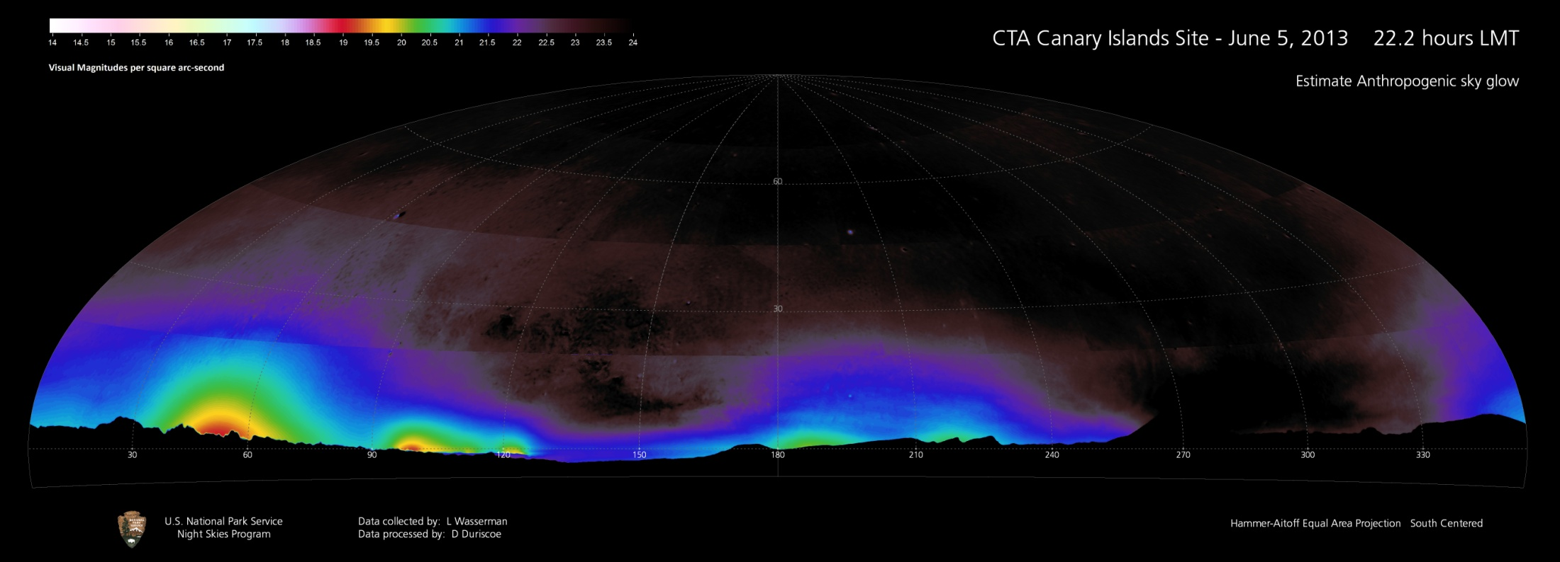
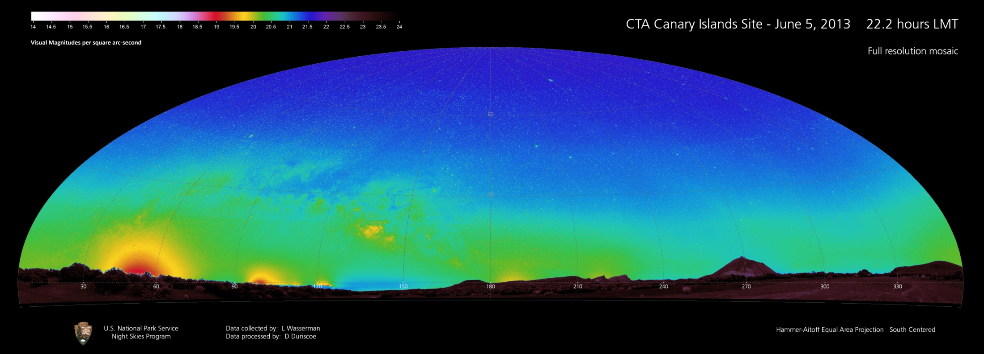
2
1
Figures 1-2. Full resolution mosaic of observed sky brightness and estimated anthropogenic sky glow in Hammer-Aitoff equal area projection (panoramic); Canary Islands Site June 5-6, 2013, 2nd data set.

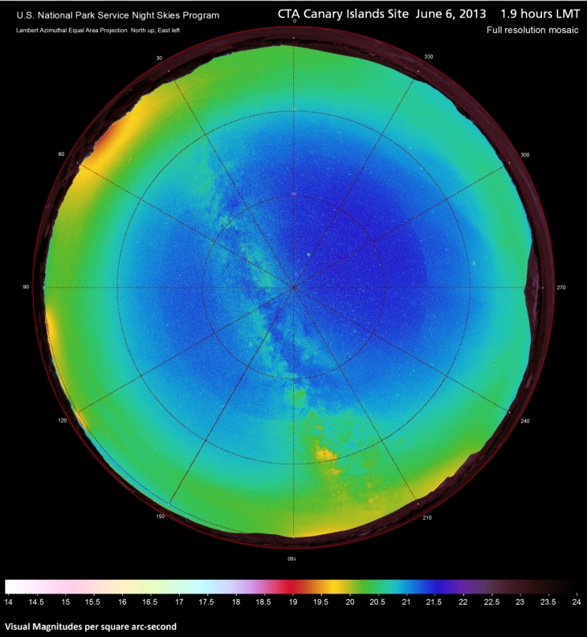
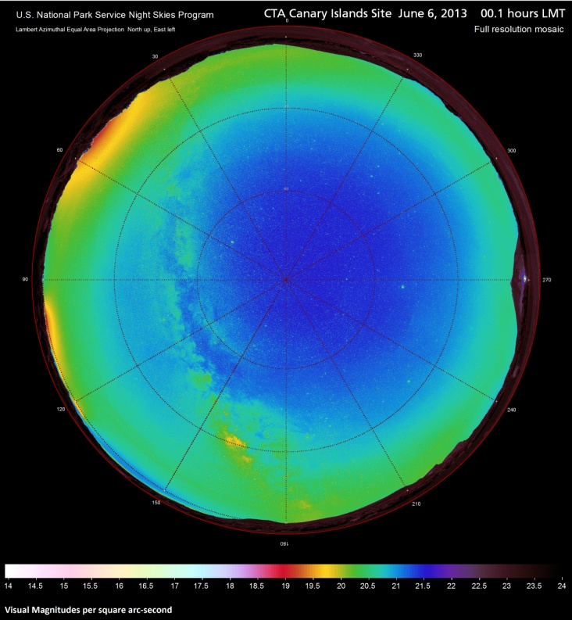
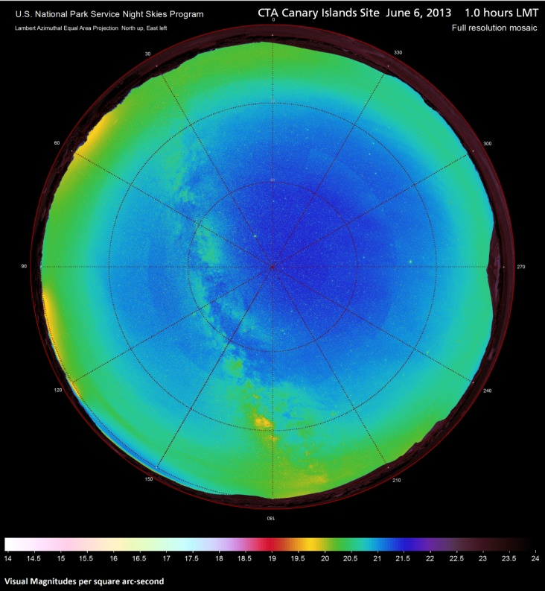
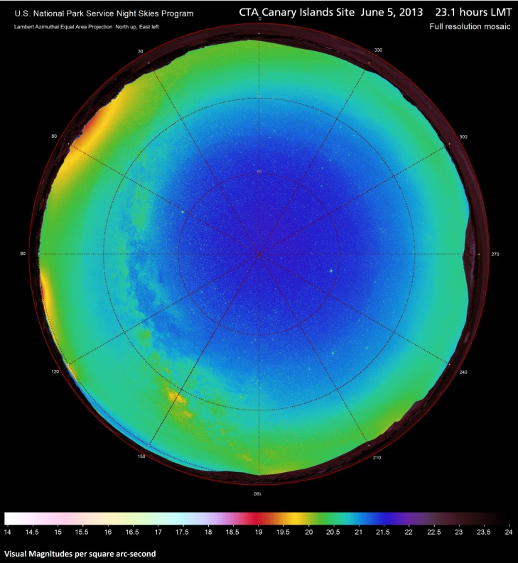
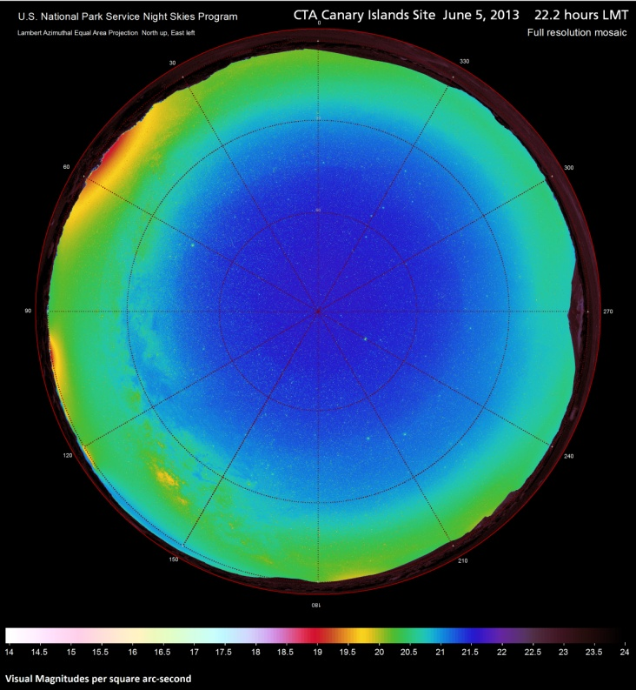
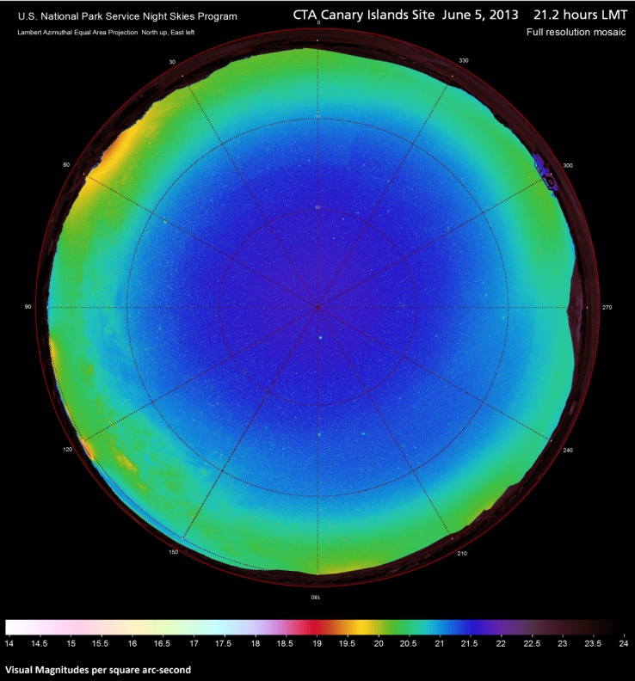
Figures 3-8. Full resolution mosaics of observed sky brightness in Lambert azimuthal equal area projection (fisheye); Canary Islands Site June 5-6, 2013.
8
7
6
5
4
3
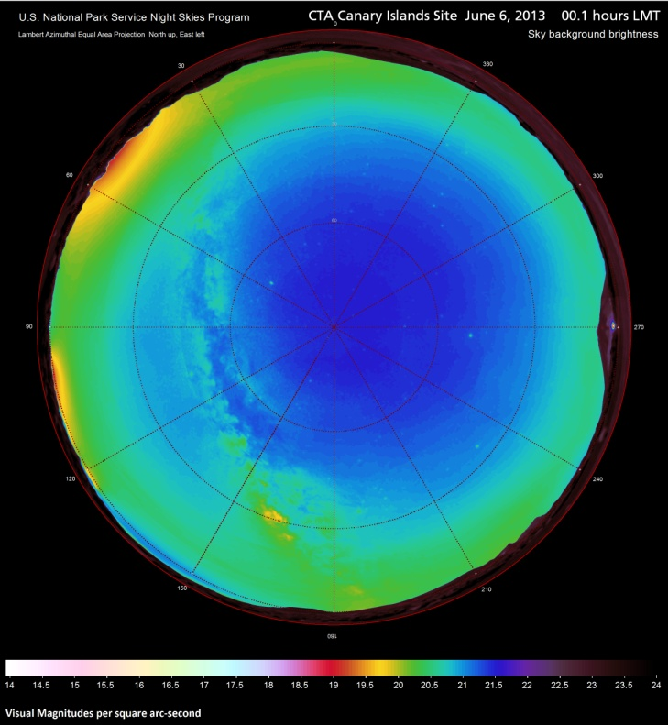
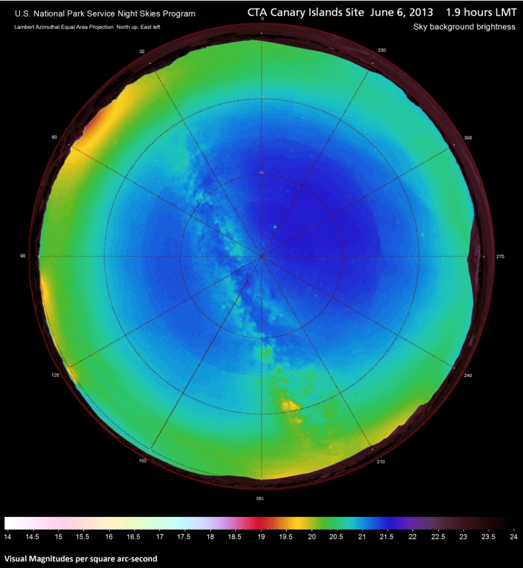
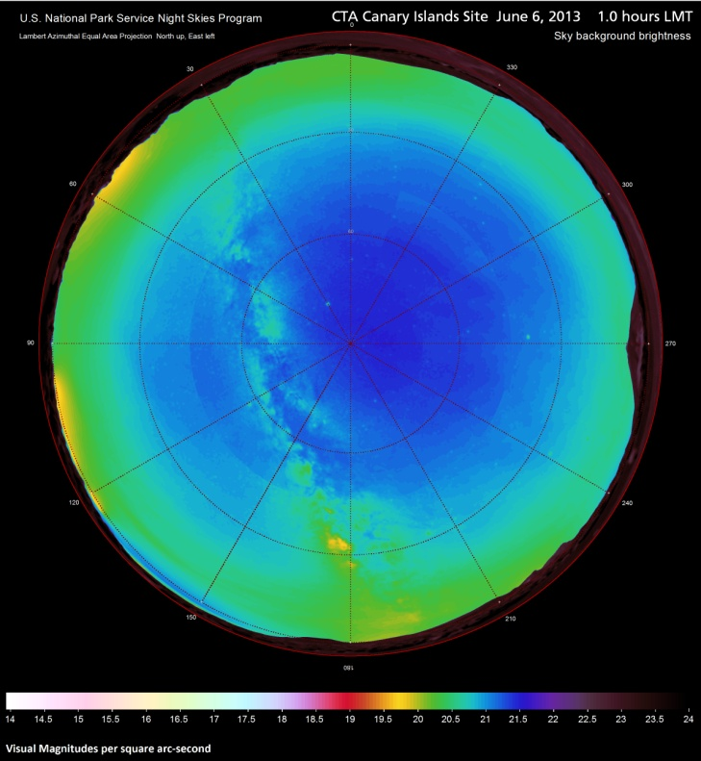
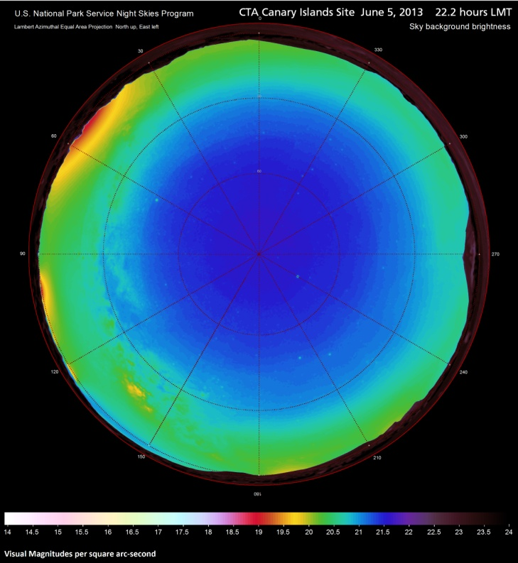
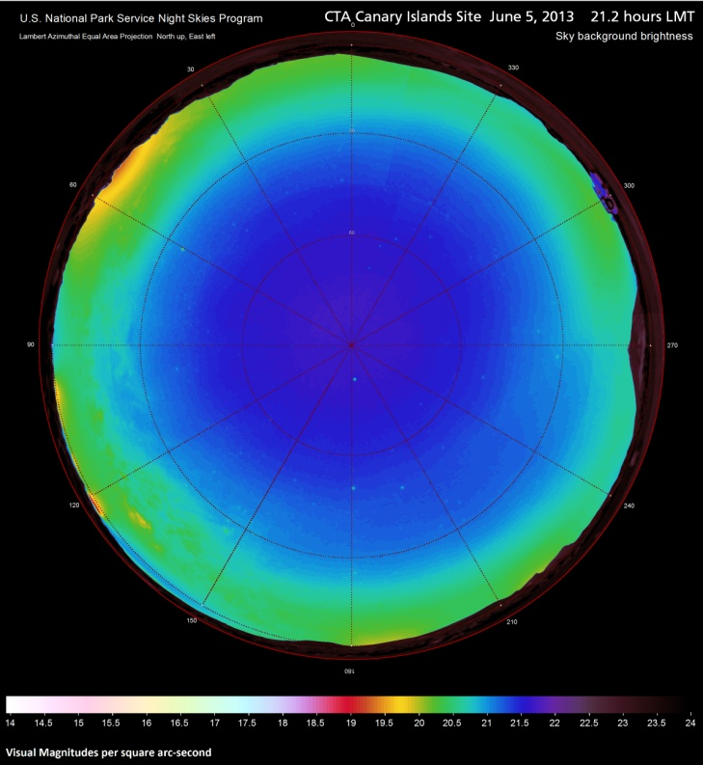
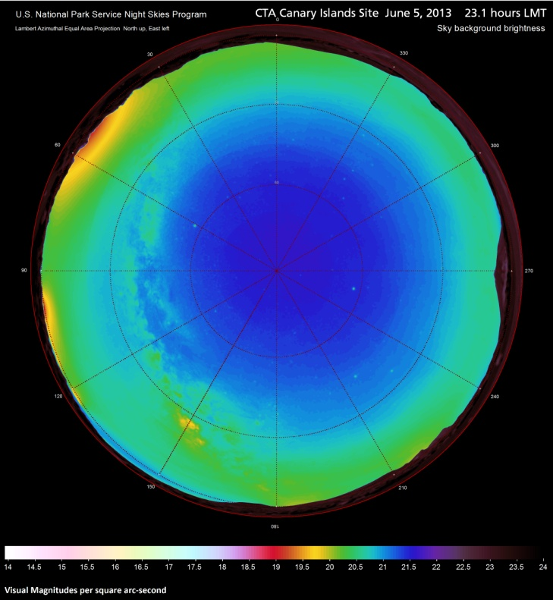
Figures 9-14. Mosaics of filtered & resampled observed sky brightness in Lambert azimuthal equal area projection (fisheye); Canary Islands Site June 5-6, 2013.
14
13
12
11
10
9

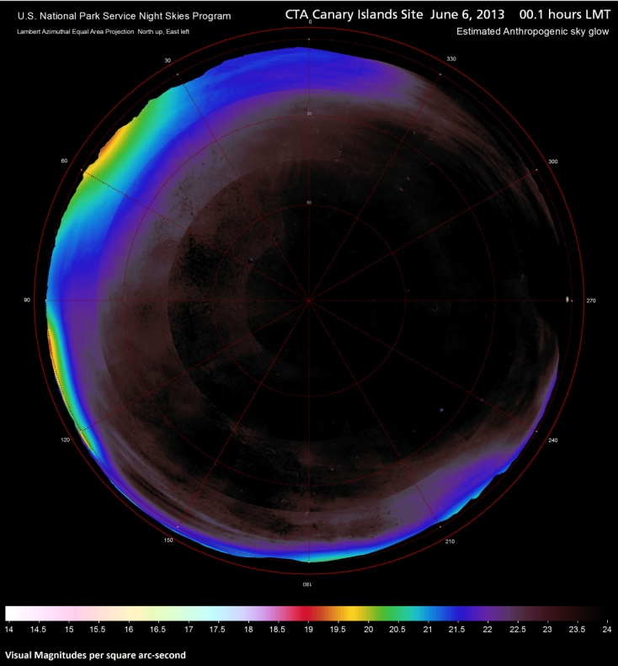
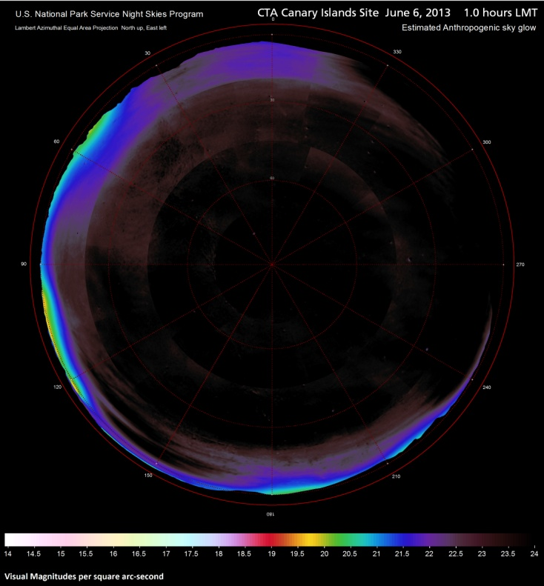
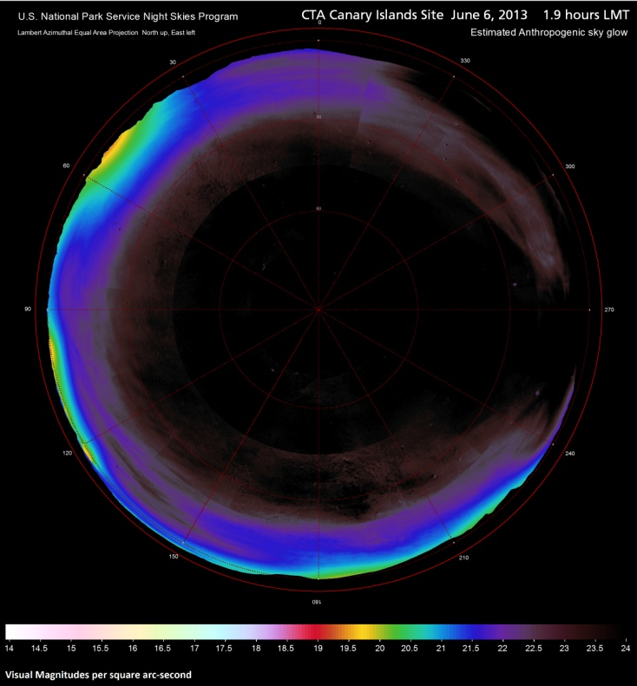
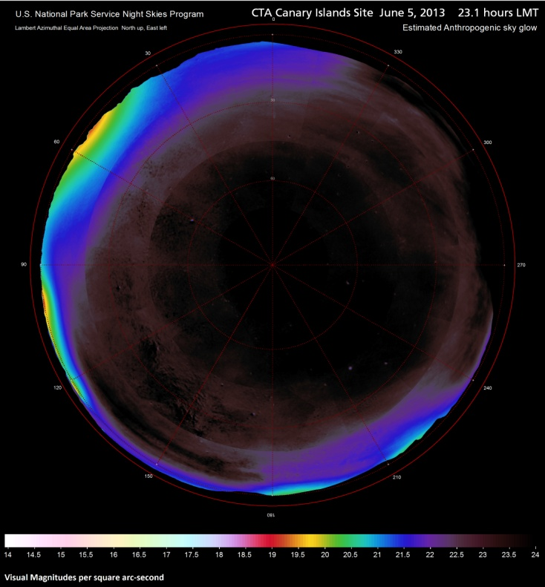
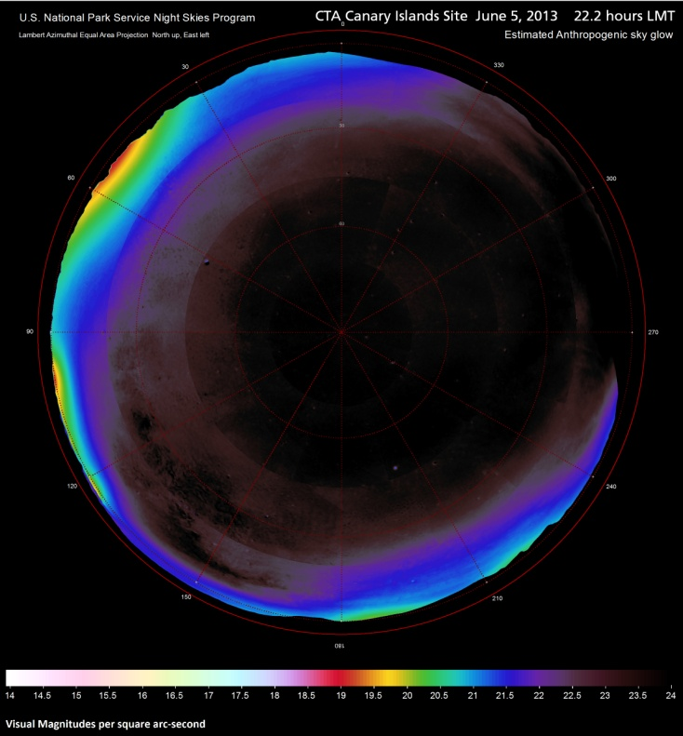
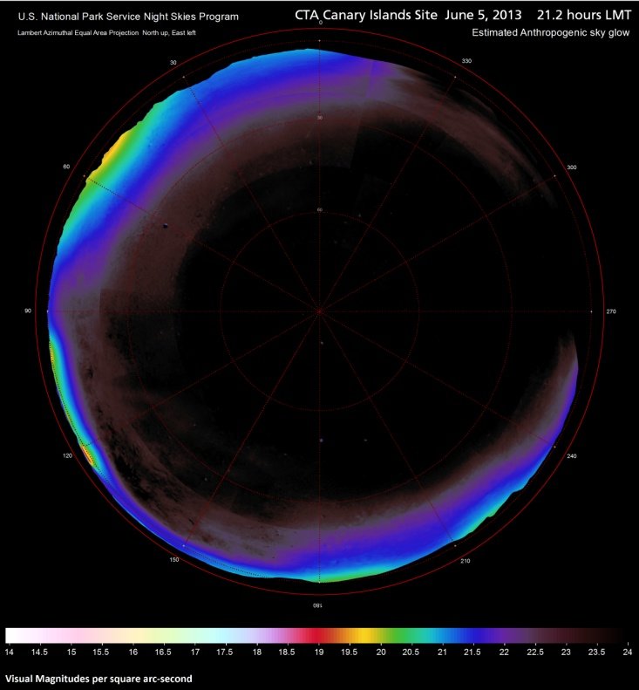
Figures 15-20. Mosaics of estimated anthropogenic sky glow in Lambert azimuthal equal area projection (fisheye); Canary Islands Site June 5-6, 2013.
15
20
19
18
17
16
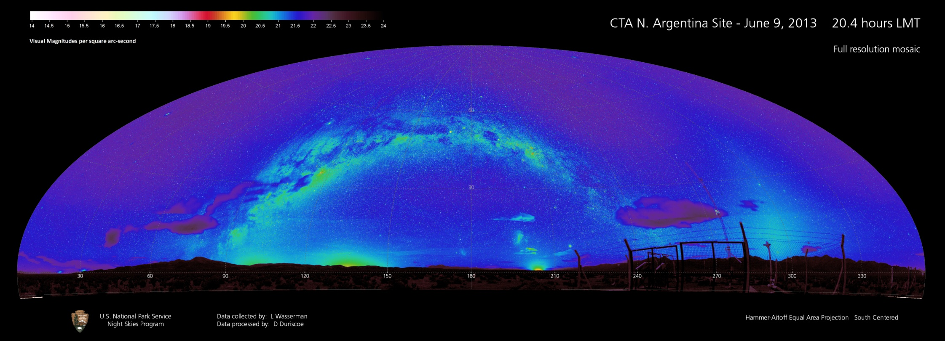
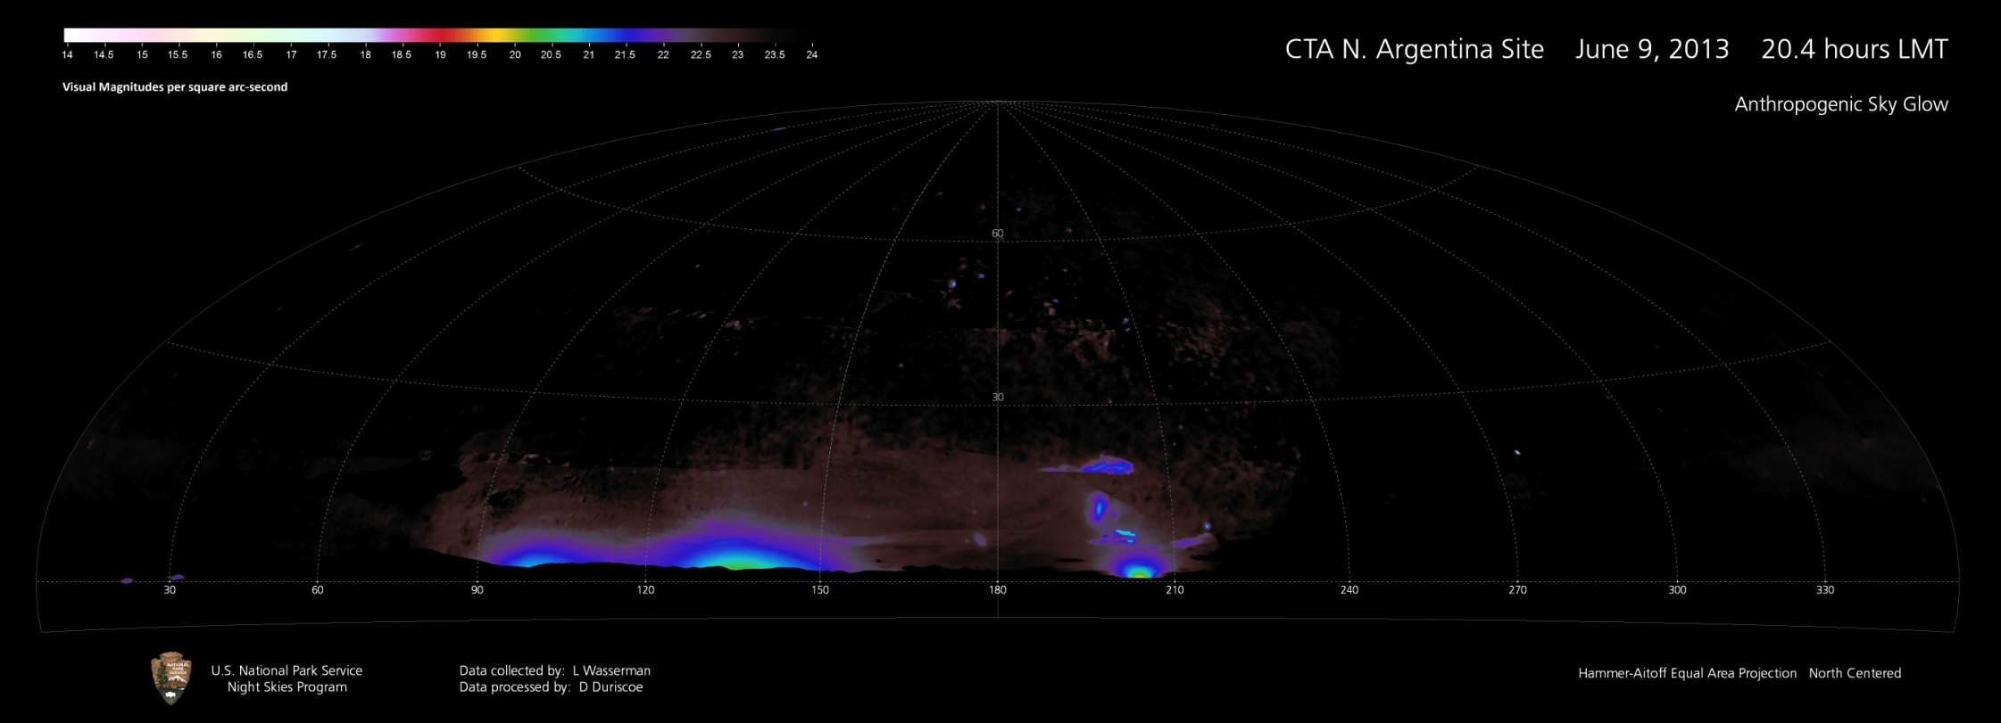
Figures 21-22. Full resolution mosaic of observed sky brightness and estimated anthropogenic sky glow in Hammer-Aitoff equal area projection (panoramic); Northern Argentina Site June 9-10, 2013, 2nd data set.
22
21
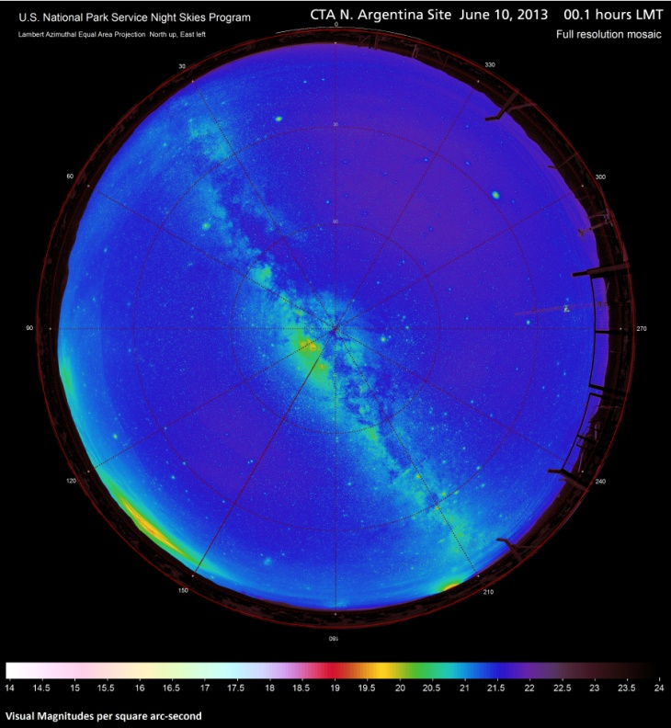
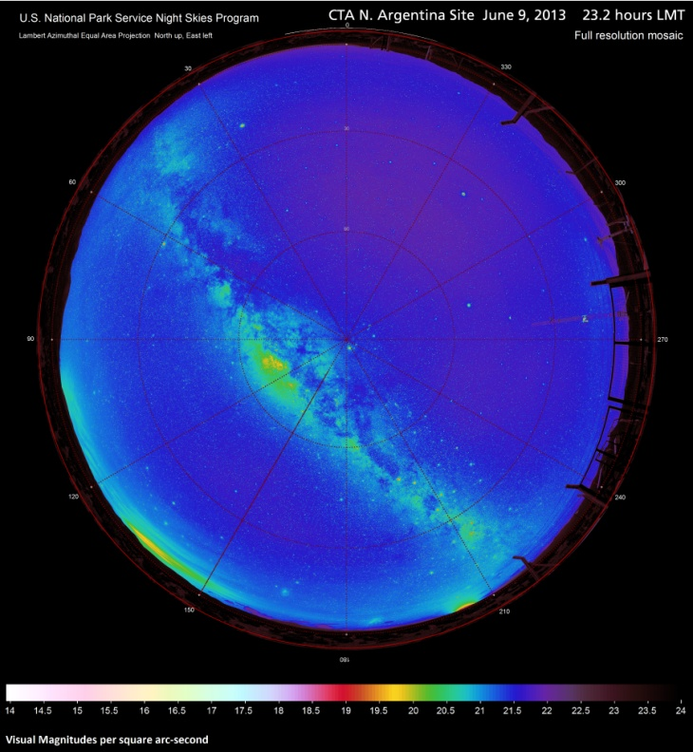
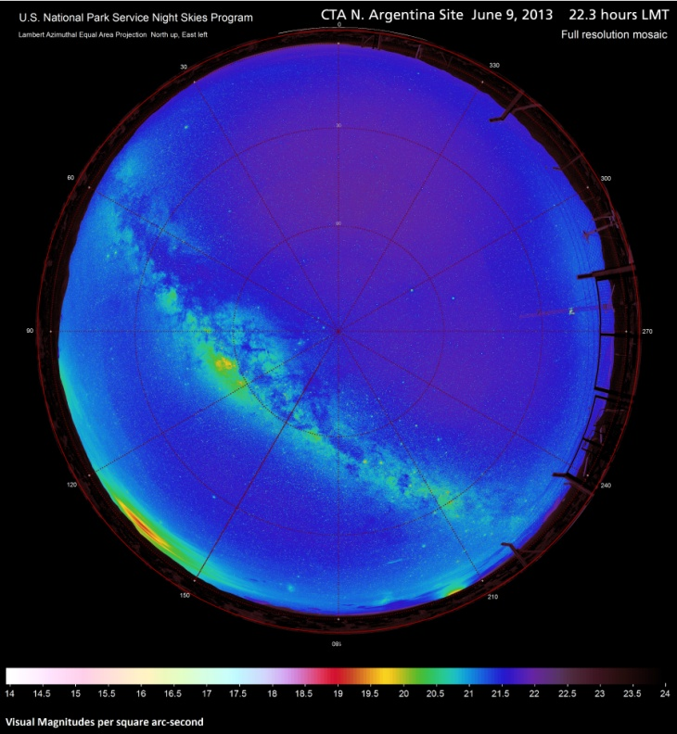
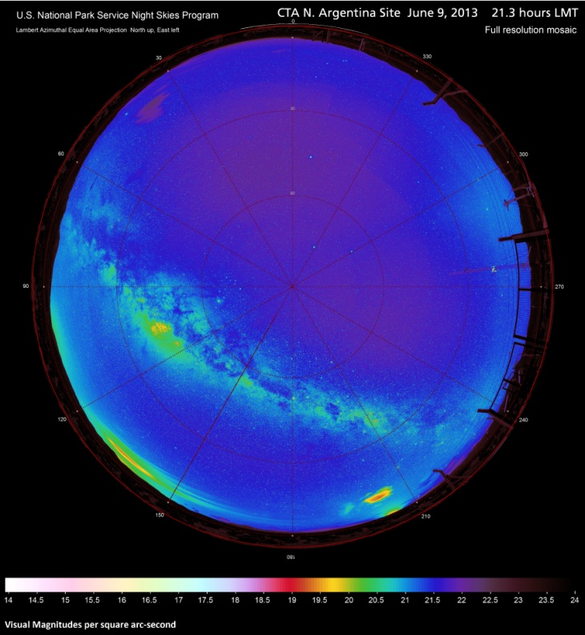
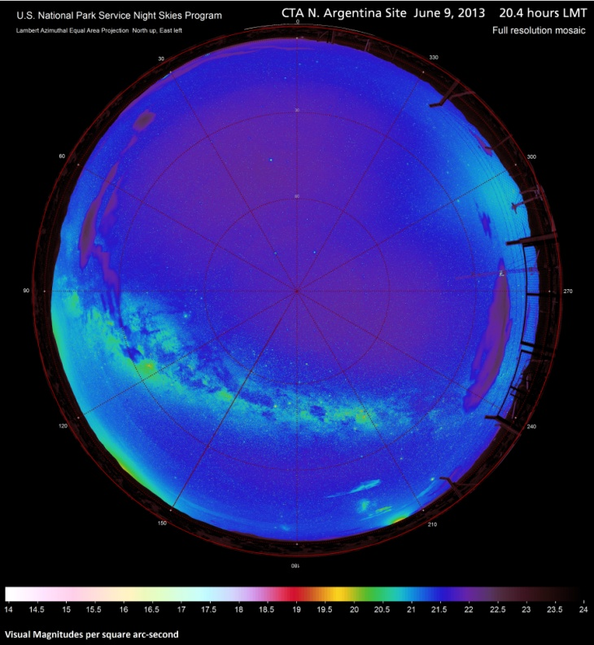
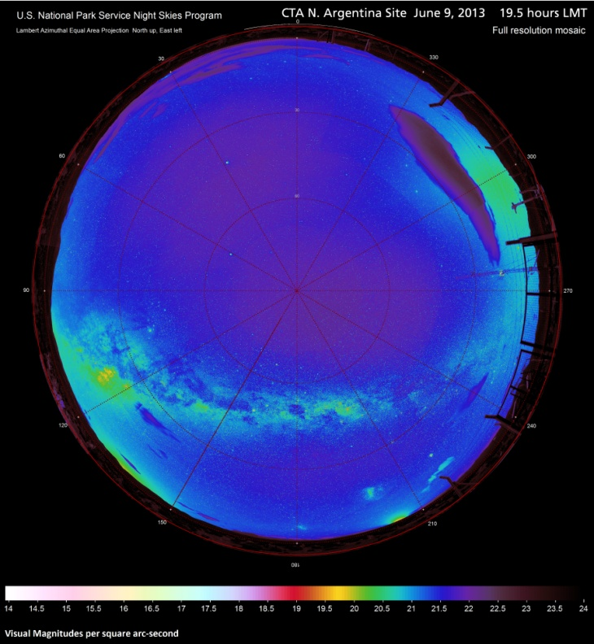
Figures 23-28. Full resolution mosaics of observed sky brightness in Lambert azimuthal equal area projection (fisheye); N. Argentina Site June 9-10, 2013.
26
25
24
23
28
27
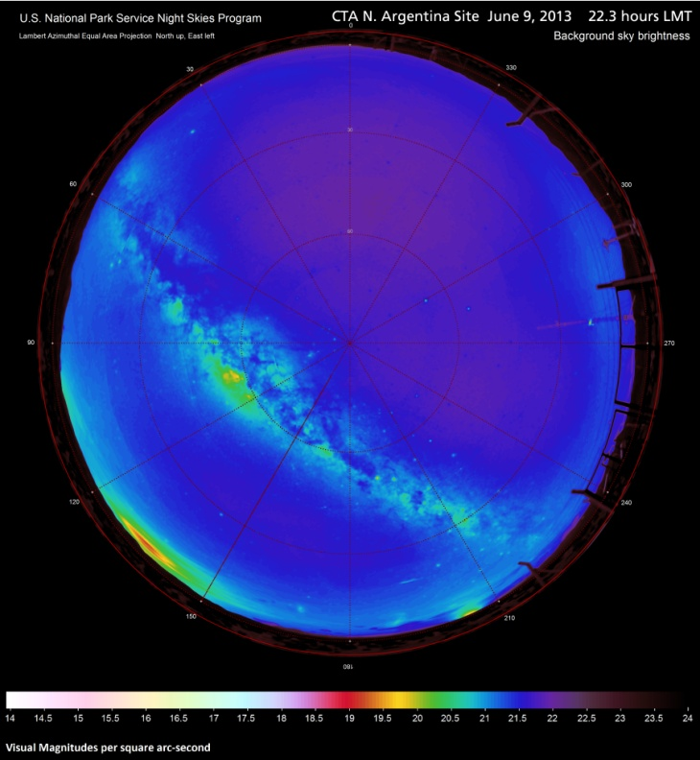
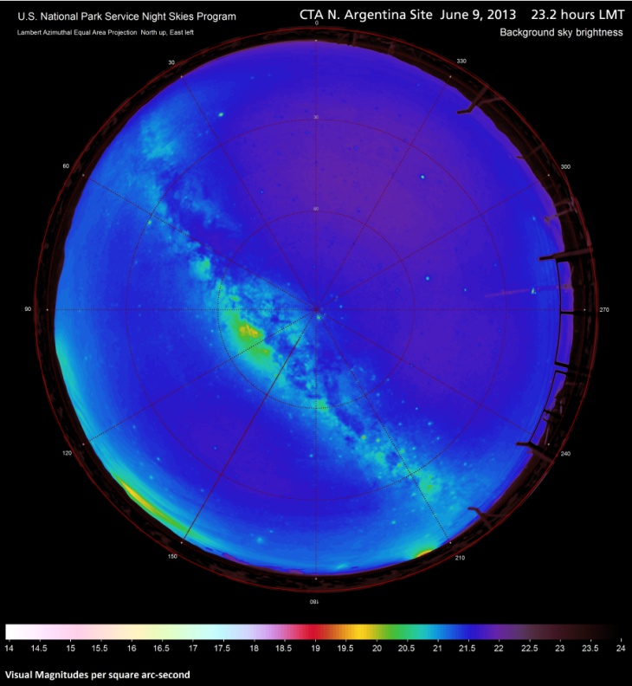
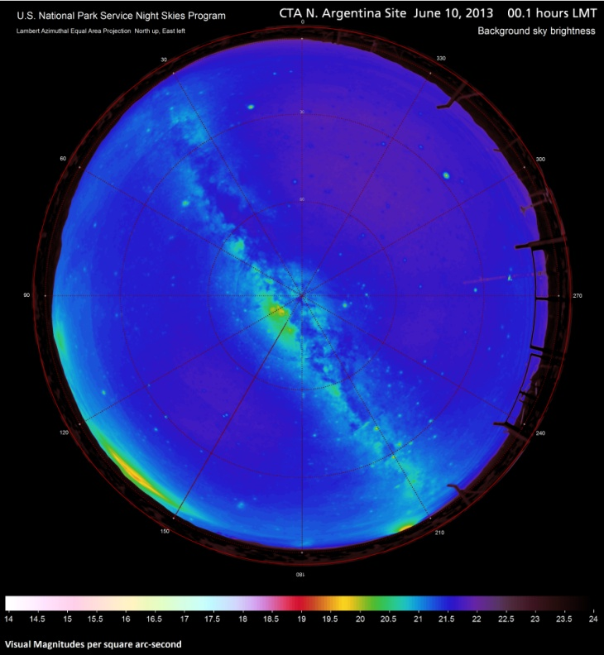
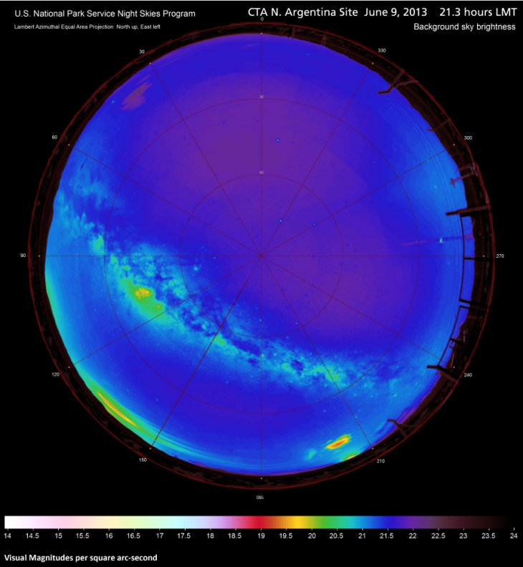
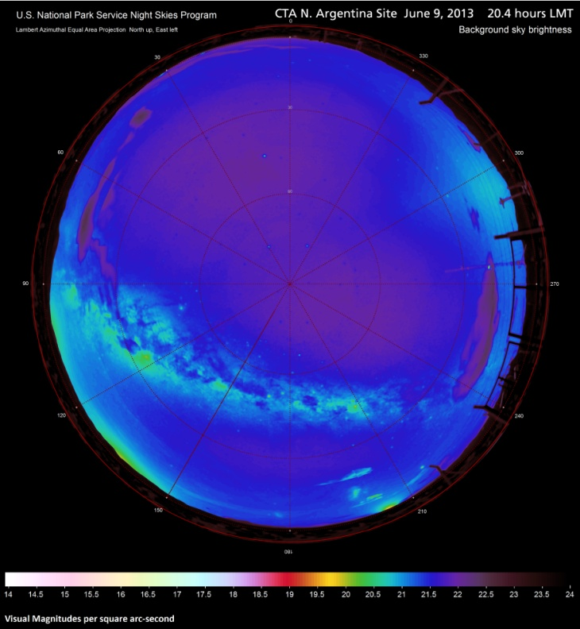
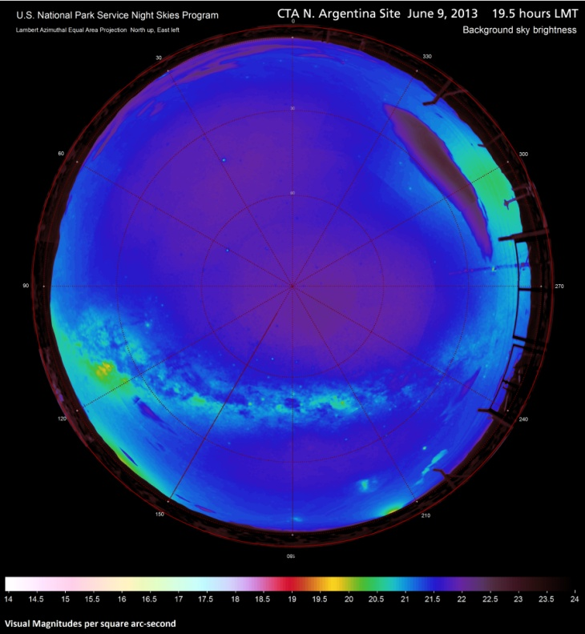
Figures 29-34. Mosaics of filtered & resampled observed sky brightness in Lambert azimuthal equal area projection (fisheye); N. Argentina Site June 9-10, 2013.
32
31
30
29
34
33
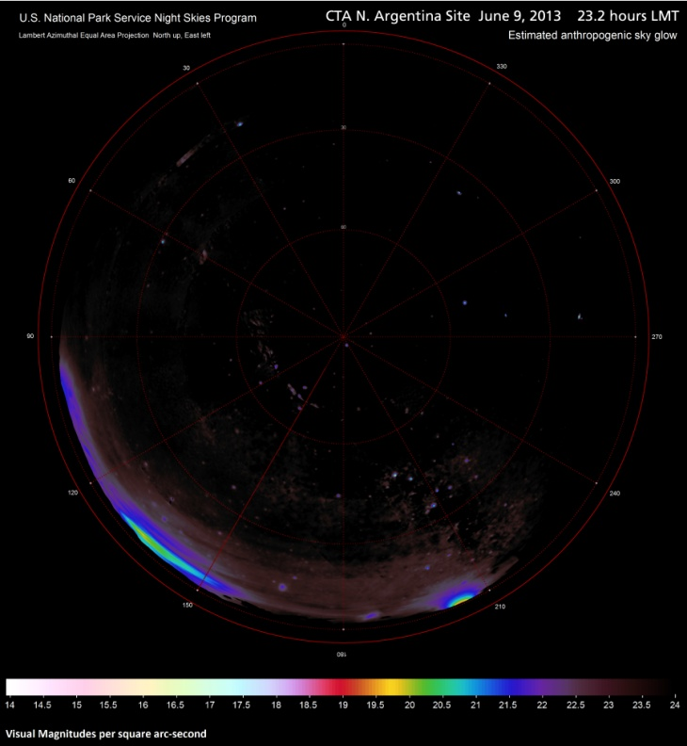
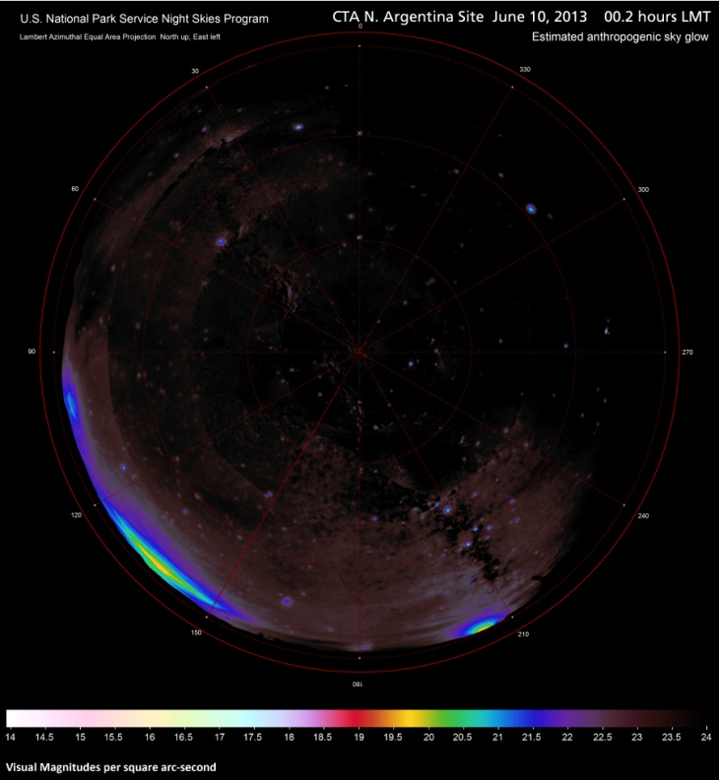
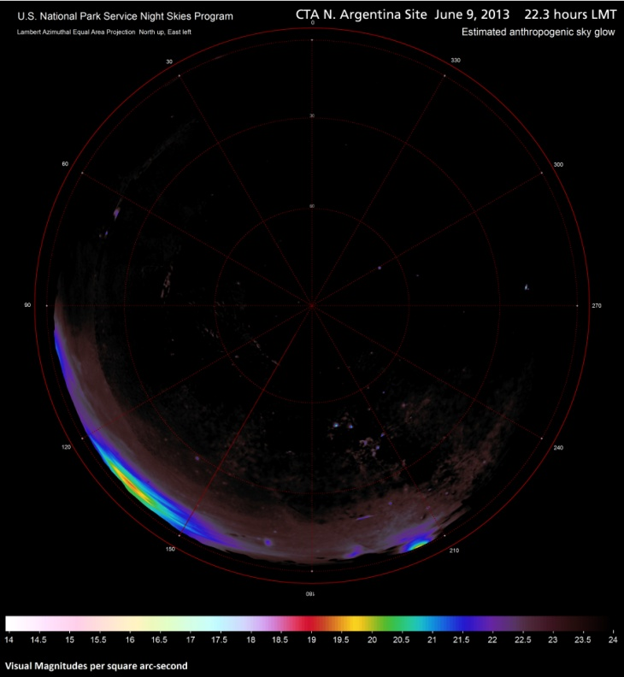
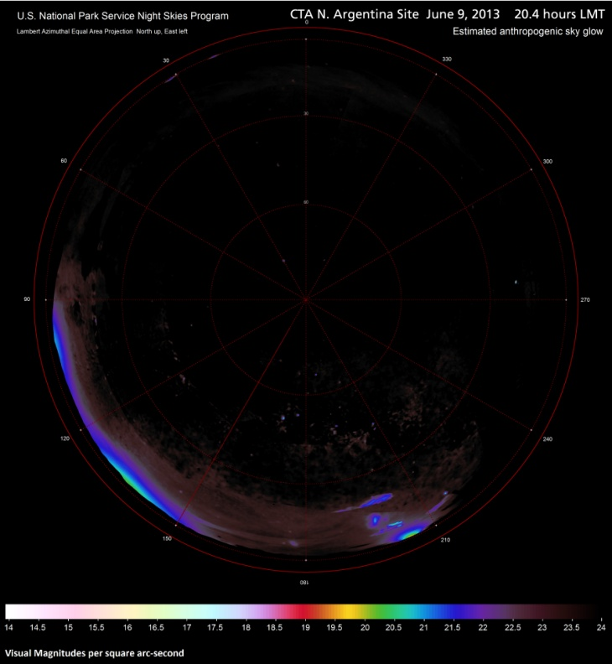
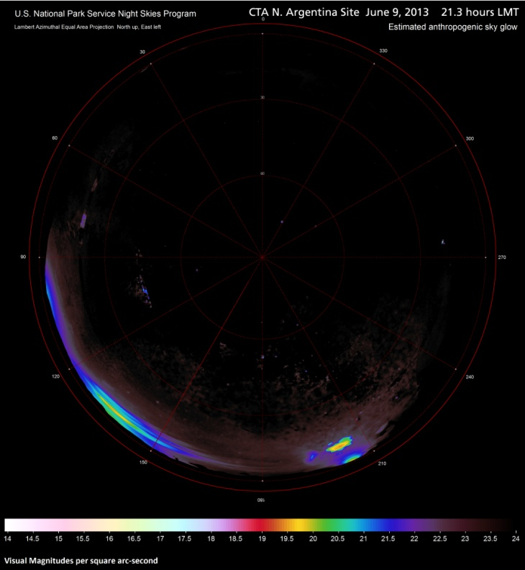
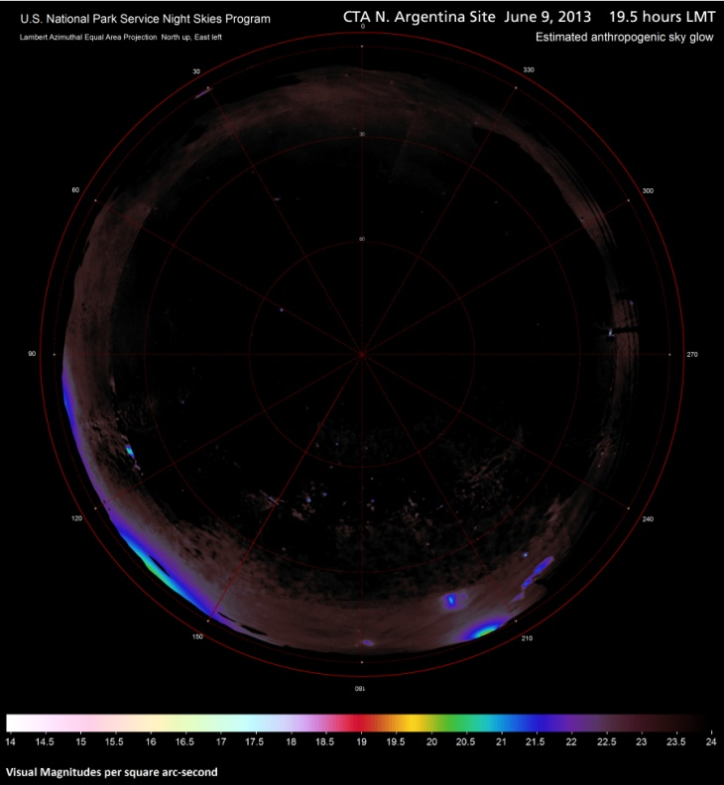
Figures 35-40. Mosaics of estimated anthropogenic sky glow in Lambert azimuthal equal area projection (fisheye); N. Argentina Site June 9-10, 2013.
38
37
36
35
40
39
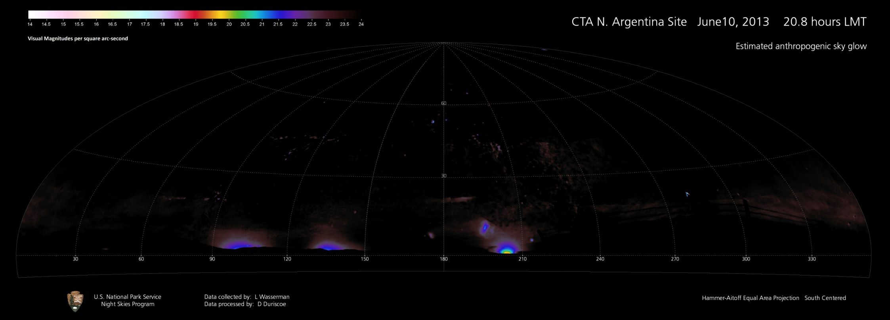
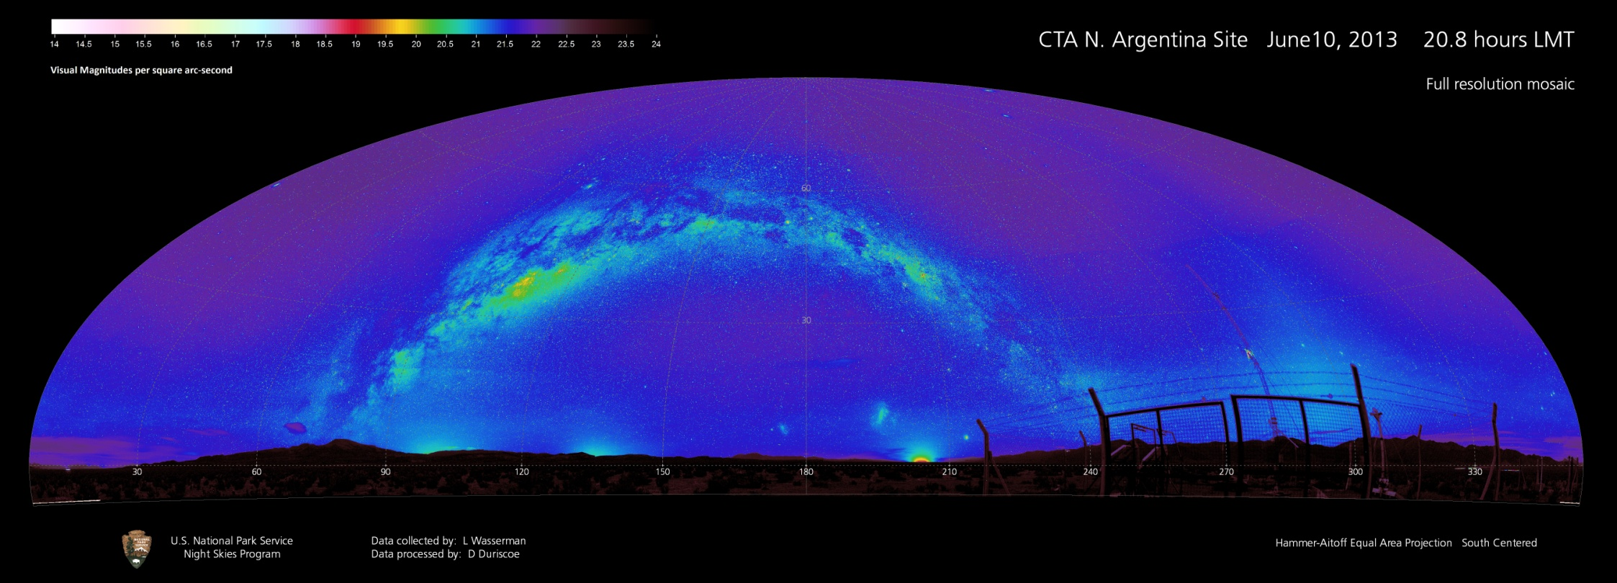
Figures 41-42. Full resolution mosaic of observed sky brightness and estimated anthropogenic sky glow in Hammer-Aitoff equal area projection (panoramic); Northern Argentina Site June 10-11, 2013, 1st data set.
41
42
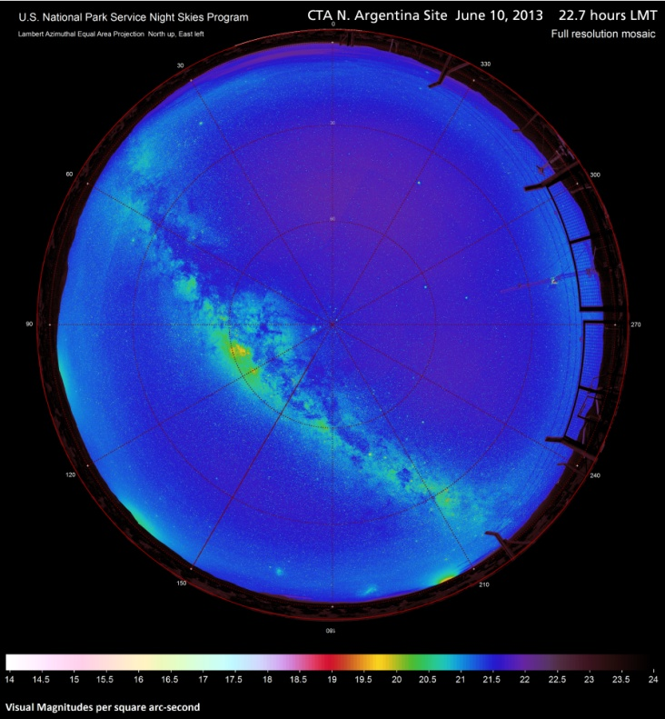
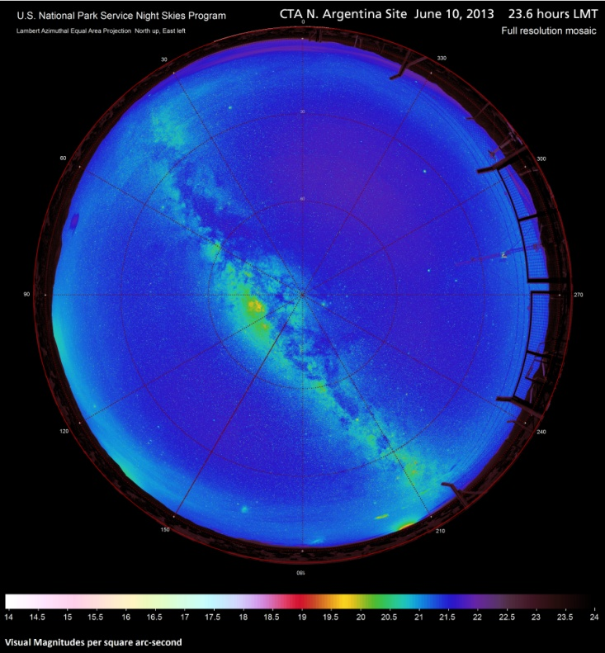
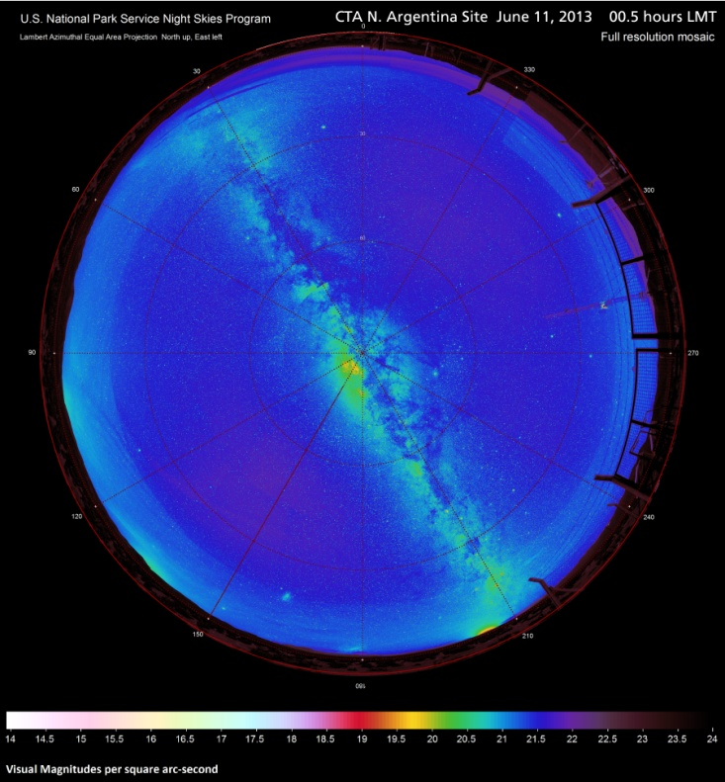
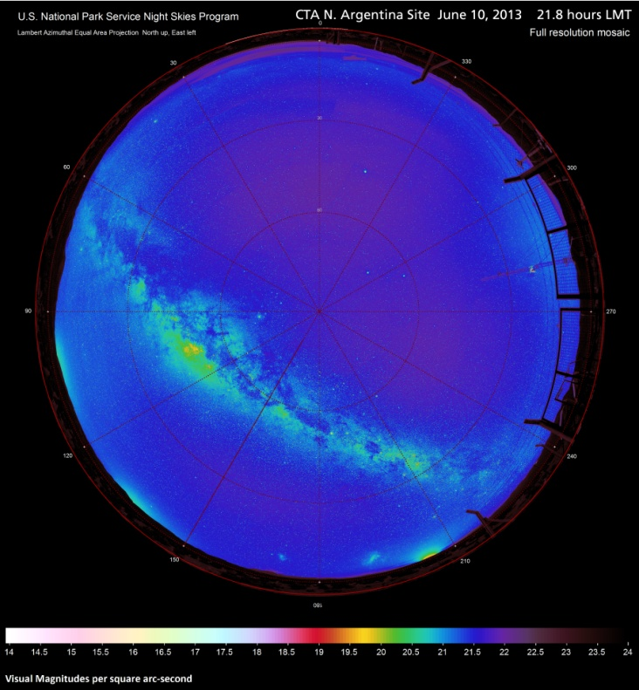
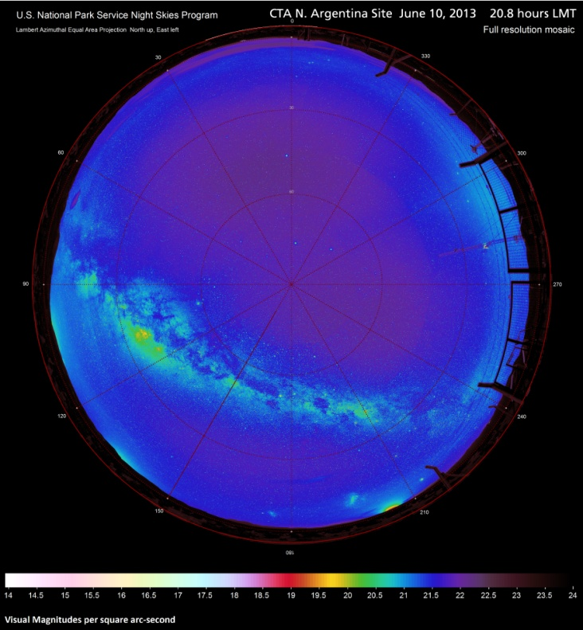
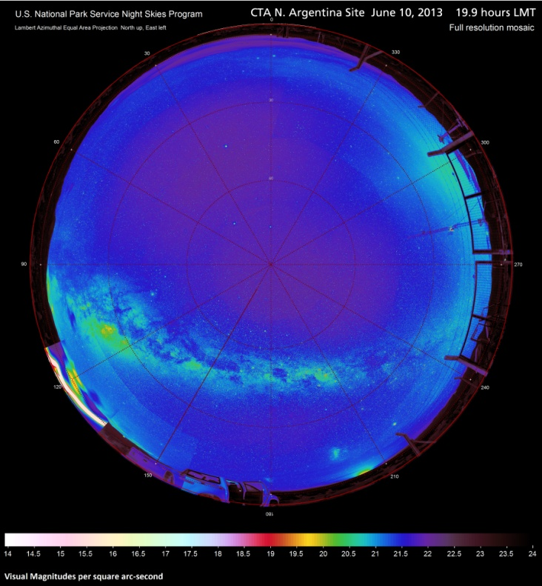
Figures 43-48. Full resolution mosaics of observed sky brightness in Lambert azimuthal equal area projection (fisheye); N. Argentina Site June 10-11, 2013.
43
48
47
46
45
44
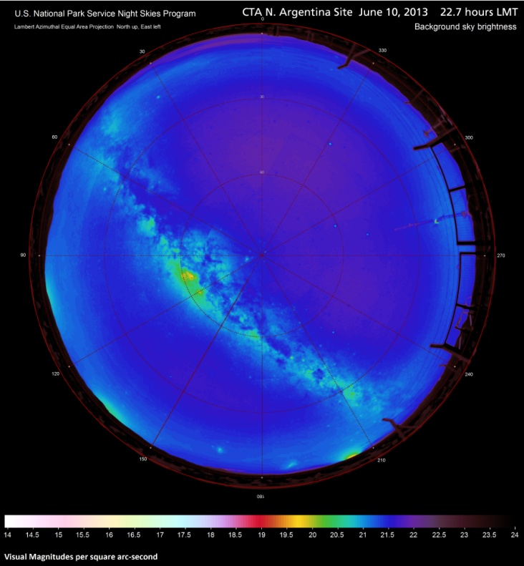
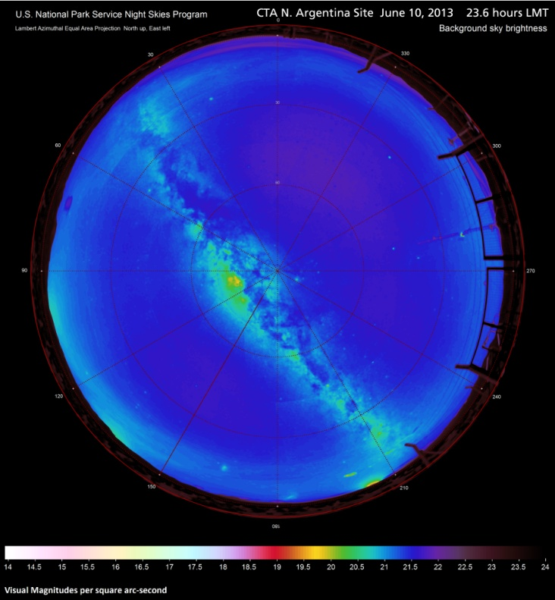
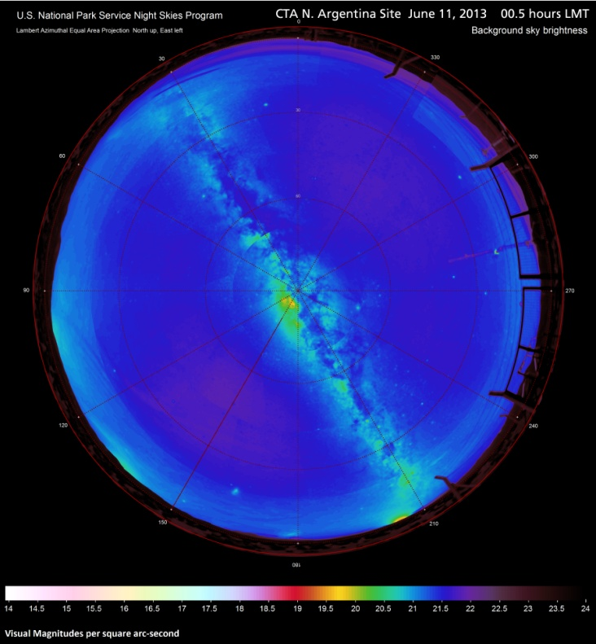
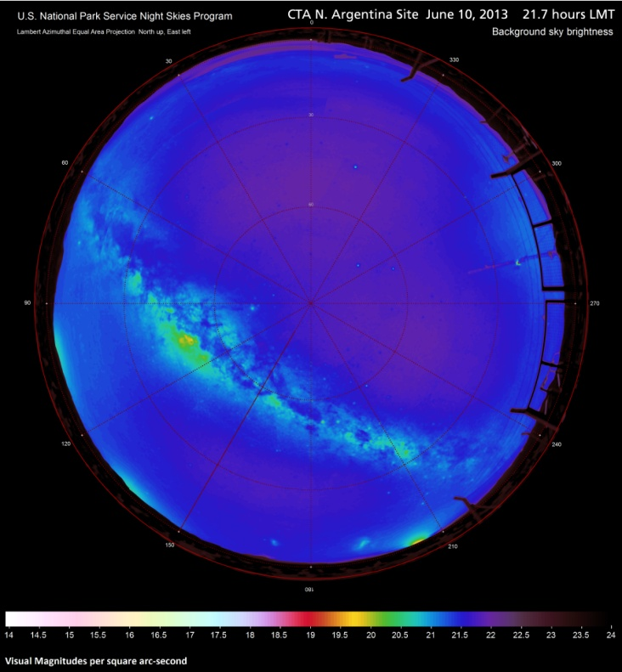
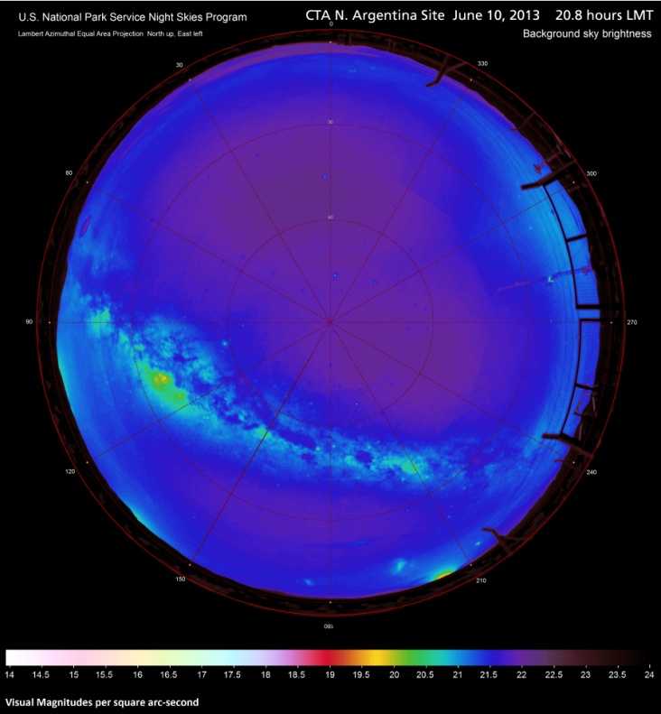
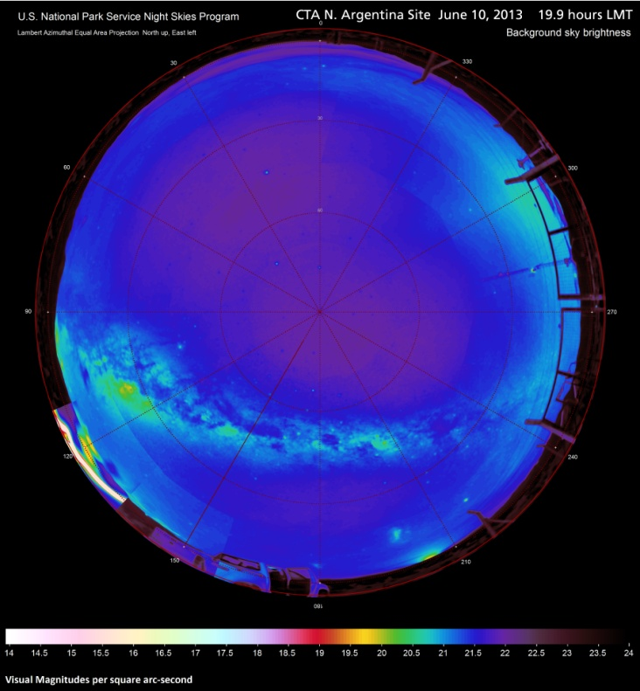
Figures 49-54. Mosaics of filtered & resampled observed sky brightness in Lambert azimuthal equal area projection (fisheye); N. Argentina Site June 10-11, 2013.
49
54
53
52
51
50
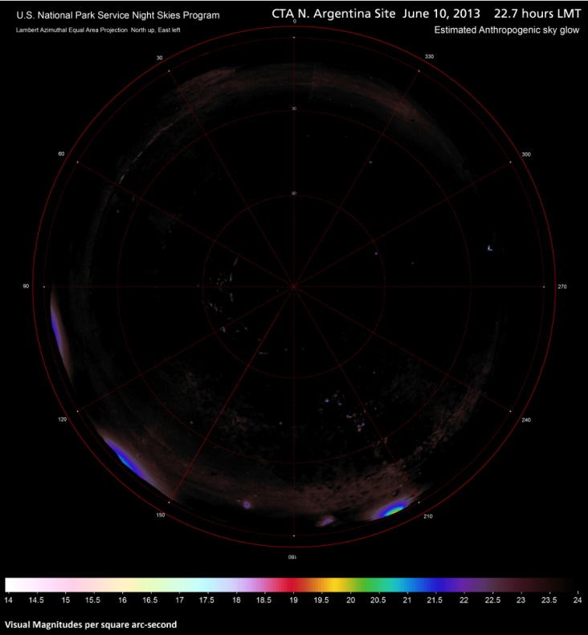
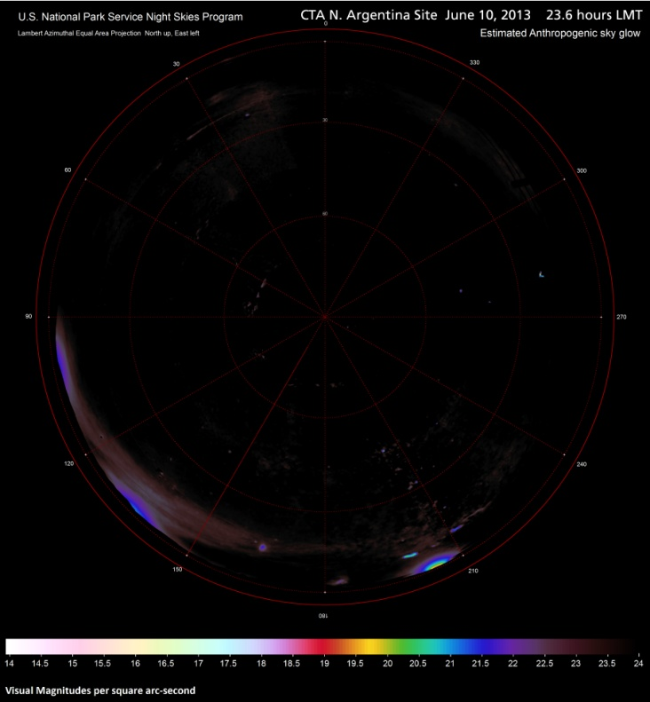
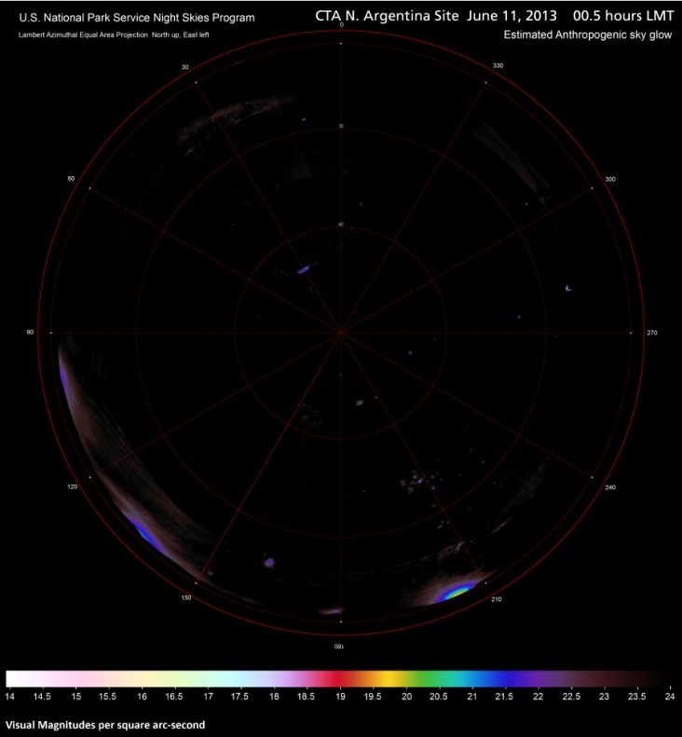
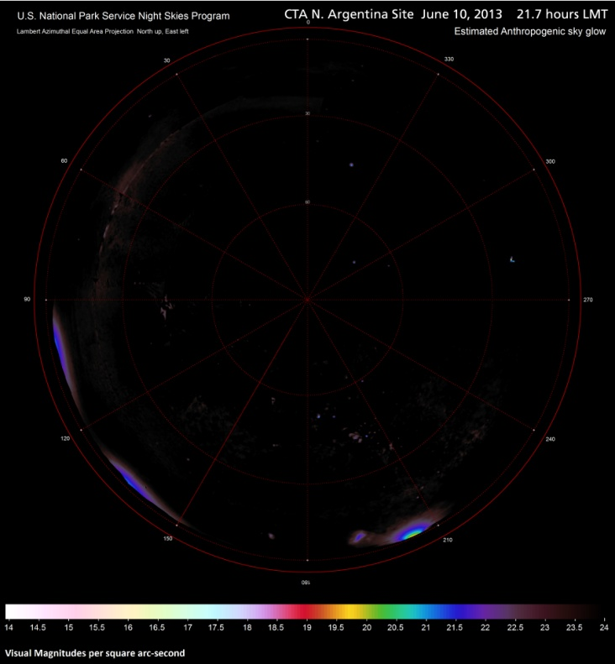
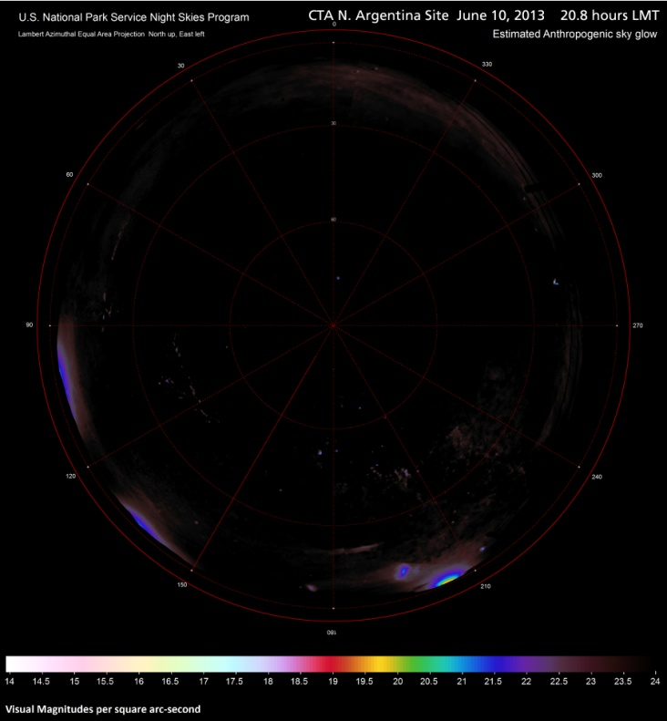
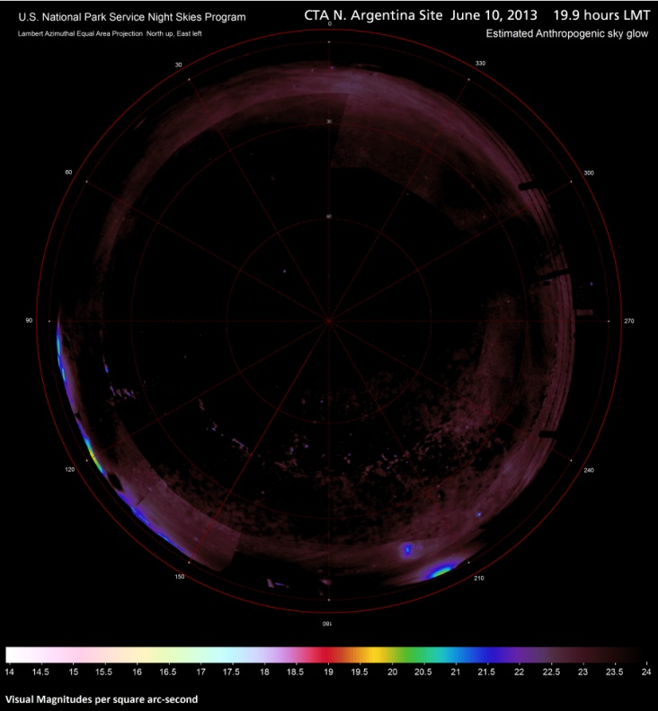
Figures 55-60. Mosaics of estimated anthropogenic sky glow in Lambert azimuthal equal area projection (fisheye); N. Argentina Site June 10-11, 2013.
57
56
55
60
59
58

